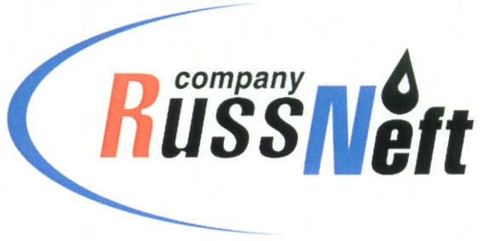
PJSC “RUSSNEFT” PRESS SERVICE

Tel.: (495) 411-63-24; (495) 411-63-21  Fax: (495) 411-63-19  E-mail: pr@russneft.ru  www.russneft.ru | 115054, Moscow,  Pyatnitskaya str., 69

PRESS - RELEASE
October 10, 2023

The Saratov branch of RussNeft summed up the results of the scientific and technical conference of its young specialists

PJSC "RussNeft" summed up the results of the scientific and technical conference of young specialists in Saratov. Eight projects were presented to the competition committee, including one team work.

The evaluation of projects was based on the following criteria: relevance, economic feasibility and efficiency, originality and feasibility. The competition committee noted the thematic diversity of the proposed new solutions for oil and oily wastewater treatment, metal cutting technology, and power grid operating modes control.

The following projects were recognized as winners: “6-10 kV power grids operating modes control with smart breakers” by Andrey Nesterov (I place); “Pipeline leak detection system implementation” by Nikita Krasechkov and Valery Gavrilov (II place); “Line heater coils upgrade” by Alexandr Guskov (III place). The winners received memorable diplomas, as well as incentive cash payments. Also, diplomas were awarded to young specialists who won in the categories “Implementation possibility advantages”, “Best innovation proposal”, “Project best presentation”.

Scientific and technical conferences of young specialists make it possible to unlock the potential of the branch’s employees. This is an opportunity to demonstrate knowledge and abilities and contribute to the development of the production process.

About the Company:
PJSC “RussNeft” ranks among the top-10 largest oil companies by crude oil production in Russia.
The Company possesses a well-balanced portfolio of assets located in the key Russian oil and gas provinces (West Siberia, Volga-Urals and Central Siberia) as well as in Azerbaijan.
The headcount of the Company is around 8,000 employees.

Press Service of PJSC "RussNeft"
Phone: (495) 411-63-24,
Fax: (495) 411-63-19
E-mail: pr@russneft.ru

