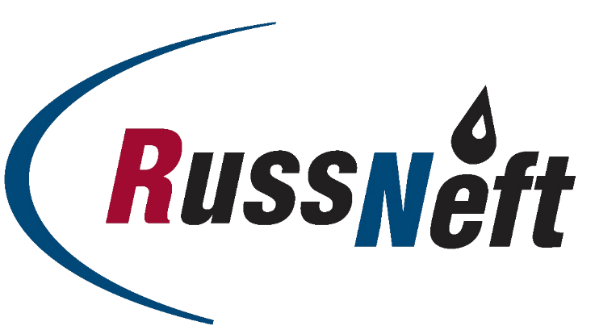

PJSC “RUSSNEFT” PRESS SERVICE

Tel.: (495) 411-63-24; (495) 411-63-21  Fax: (495) 411-63-19  E-mail: pr@russneft.ru  www.russneft.ru | 115054, Moscow,  Pyatnitskaya str., 69

PRESS RELEASE
June 27, 2022

Junior players of FC Neftyanik successfully performed at the all-Russian competitions

FC Neftyanik established under the patronage of PJSC “RussNeft”, successfully performed in the annual all-Russian Spartak Summer Cup mini-football tournament.

In the tournament, which took place in Anapa, FC Neftyanik boys’ team (born in 2011) was ranked second in its age group. Ivan Nadezhdin from Neftyanik was awarded the Best Striker of the tournament, where more than 60 teams took part.

Besides, a festive event was held at the home stadium of the football club in Novospasskoye village to honor the winners of the all-Russian tournaments among which are the girls’ team (born in 2005-2006), winner of the all-Russian final tournament Mini-football for School and the boys’ team (born 2005-2006), Breakthrough of 2022 awardee of the all-Russian mini-football tournament.

FC Neftyanik was founded in 2003 in the worker's settlement of Novospasskoye, Novospasskiy District, Ulyanovsk Region, with the support of PJSC “RussNeft”. From the moment of its foundation up to the present day the company acts as a patron of the club. More than 200 children of 7 to 17 years old are playing in FC Neftyanik.

About the Company:
PJSC “RussNeft” ranks among the top-6 largest oil companies by crude oil production in Russia.
The Company possesses a well-balanced portfolio of assets located in the key Russian oil and gas provinces (West Siberia, Volga-Urals and Central Siberia) as well as in Azerbaijan.
The headcount of the Company is around 8,000 employees.

PJSC “RussNeft” Press Service
Tel.: (495) 411-63-24, Fax: (495) 411-63-19
E-mail: pr@russneft.ru

