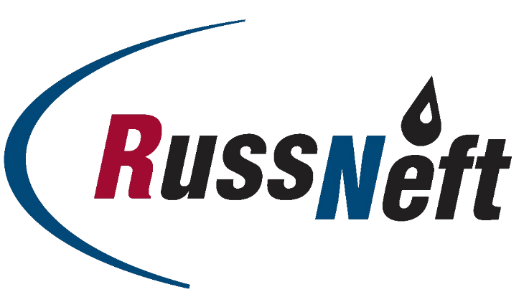

PJSC “RUSSNEFT” PRESS SERVICE

Tel.: (495) 411-63-24; (495) 411-63-21  Fax: (495) 411-63-19  E-mail: pr@russneft.ru  www.russneft.ru | 115054, Moscow,  Pyatnitskaya str., 69

PRESS RELEASE
February xx, 2023

Neftyanik has reached the final of the All-Russian mini-football tournament

The Neftyanik football club became the winner of the regional stage of the all-Russian project "Mini-football to school".

The girls' team of the club, created under the patronage of PJSC “RussNeft”, represented the Ulyanovsk Region at the regional stage, where the teams of the Volga Federal District competed.

Ulyanovsk football girls had a landslide victory and won the right to perform in the finals of All-Russian competitions.

The project "Mini-football to school" is implemented by the Association of mini-football of Russia together with the Ministry of Sports of the Russian Federation. The project is one of the most popular sports competitions for boys and girls. Its concept involves providing a comprehensive solution to the problems of motor activity and strengthening the health of schoolchildren.

About the Company:
PJSC “RussNeft” ranks among the top-10 largest oil companies by crude oil production in Russia.
The Company possesses a well-balanced portfolio of assets located in the key Russian oil and gas provinces (West Siberia, Volga-Urals and Central Siberia) as well as in Azerbaijan.
The headcount of the Company is around 8,000 employees.

PJSC “RussNeft” Press Service
Tel.: (495) 411-63-24, Fax: (495) 411-63-19
E-mail: pr@russneft.ru

