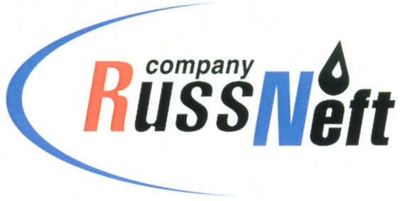
PJSC “RUSSNEFT”
PRESS SERVICE

Tel.: (495) 411-63-24; (495) 411-63-21  Fax: (495) 411-63-19  E-mail: pr@russneft.ru  www.russneft.ru | 115054, Moscow,  Pyatnitskaya str., 69

PRESS - RELEASE
April 4, 2024
RussNeft supports young employees` professional initiatives

PJSC “RussNeft” has held the First Scientific and Technical Conference of the Company's young professionals.
The main objective of the conference, which took place on the basis of the Nizhnevartovsk branch, is to improve the skills and enhance the research activities of the holding's talent pool. The event is aimed at identifying and supporting advanced ideas and initiatives, as well as the most talented and promising young employees of RussNeft.
The conference was attended by specialists from Nizhnevartovsk, Khanty-Mansiysk, Tomsk, Saratov and Ulyanovsk branches of the company. All of them are winners of similar conferences in the branches. At the final stage, the jury reviewed projects for improving the efficiency and rationalization of production through the introduction of innovative solutions. When evaluating reports and presentations, the economic feasibility, relevance, and originality of the topic developed were taken into consideration. Following the results of the conference, the winners were determined, and their works were awarded.

About the Company:
PJSC “RussNeft” ranks among the top-10 largest oil companies by crude oil production in Russia.
The Company possesses a well-balanced portfolio of assets located in the key Russian oil and gas provinces (West Siberia, Volga-Urals and Central Siberia) as well as in Azerbaijan.
The headcount of the Company is around 7,000 employees.

Press Service of PJSC "RussNeft"
Phone: (495) 411-63-24
Fax: (495) 411-63-19
E-mail: pr@russneft.ru

