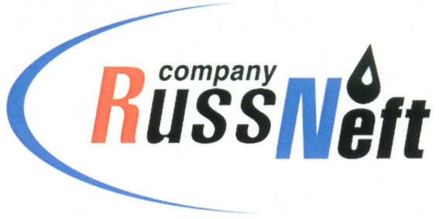
PJSC “RUSSNEFT”
PRESS SERVICE

Tel.: (495) 411-63-24; (495) 411-63-21  Fax: (495) 411-63-19  E-mail: pr@russneft.ru  www.russneft.ru | 115054, Moscow,  Pyatnitskaya str., 69

PRESS - RELEASE
October 25, 2022
RussNeft conducts a professional skills review contest among drivers

Nizhnevartovsk branch of PJSC “RussNeft” held "Best in Profession" professional skills contest among car drivers on the occasion of the Day of Road Transport Workers.
The professional contest brought together 11 drivers of the Technological Transport Department of the branch. The program of two-stage review contest included both theoretical and practical competitions where the professional skills were estimated on motordrome.
The winners of the contest were awarded the "Best in Profession" title and an annual salary supplement was established for professional skills and high qualifications. The main purpose of the event is to establish corporate labor standards based on the review and distribution of best practices and production standards, encouraging the workers to improve their professional skills, developing creative activity, improving production efficiency and quality of work.

About the Company:
PJSC “RussNeft” ranks among the top-10 largest oil companies by crude oil production in Russia.
The Company possesses a well-balanced portfolio of assets located in the key Russian oil and gas provinces (West Siberia, Volga-Urals and Central Siberia) as well as in Azerbaijan.
The headcount of the Company is around 8,000 employees.

Press Service of PJSC "RussNeft"
Phone: (495) 411-63-24
Fax: (495) 411-63-19
E-mail: pr@russneft.ru

