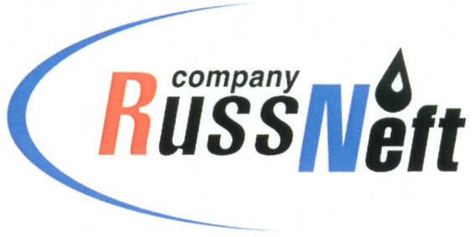
PJSC “RUSSNEFT” PRESS SERVICE
PRESS-RELEASE
Tel.: (495) 411-63-24; (495) 411-63-21  Fax: (495) 411-63-19  E-mail: pr@russneft.ru  www.russneft.ru | 115054, Moscow,  Pyatnitskaya str., 69

PRESS-RELEASE
February 8, 2018

Reserves replacement ratio of “RussNeft” is 176% in 2017

Increase in reserves of PJSC “RussNeft” in 2017 amounted to 12.3 million tonnes, while the reserves replacement ratio was 176%.
The bulk of geological exploration works has been fulfilled in Khanty-Mansi Autonomous District.
During prospecting and appraisal phase, 1 000 km of 2D seismic survey was carried out at Zapadno-Uzunskiy, Pikovy and Khantymansiysko-Frolovskiy licence areas for detailing of promising oil and gas facilities by the time of exploratory drilling.
At Verkhne-Shapshinskiy and Sredne-Shapshinskiy licences, 160 km² of 3D seismic survey was conducted in order to obtain detailed geological structure and delineation of pay zones.
The reserves growth of “RussNeft” was mainly provided by Shapshinskaya Group of Oilfields. In 2017, the Company implemented the programme of old exploratory well stock re-testing, which yielded natural oil flows of 70-100 tonnes per day. Package of exploration works allows for the current year expanding of production drilling programme at that licence area.
Testing of Bazhenov deposits at Sredne-Shapshinskoye oilfield via directional well, where the Slickwater hybrid fracturing was fulfilled, gave an inflow of 100 tonnes of oil per day.
Besides, in order to improve efficiency of production drilling at Tagrinskiy licence area, the re-interpretation of 3D seismic and borehole data was conducted in the reporting year.
At Soboliny licence area of Tomsk region the exploration well was constructed. As provided by the exploration drilling, the expected increase in recoverable oil reserves (after State Expert Review) would be around 0.3 million tons.
According to the international audit conducted, the production in 2017 was fully compensated by the increase in reserves, thus allowing for keeping the reserves at the previous year level.
The development of hard-to-recover and unconventional reserves will be a high-priority area for "RussNeft" in the midterm. The systematisation and analysis of data of geological exploration and production drilling have made it possible to rank the projects, having identified the most promising ones: Verkhne-Shapshinskoe, Tagrinskoye, Zapadno-Varioganskoye fields.

About the Company:
PJSC “RussNeft” ranks among the Top-10 largest oil companies by crude oil production in Russia.
The Company possesses a well-balanced portfolio of assets located in the key Russian oil and gas provinces (West Siberia, Volga-Urals and Central Siberia) as well as in Azerbaijan.
The number of the Company’s personnel is around 10,000.

PJSC “RussNeft” Press Service
Tel.: (495) 411-63-24, Fax: (495) 411-63-19
E-mail: pr@russneft.ru

