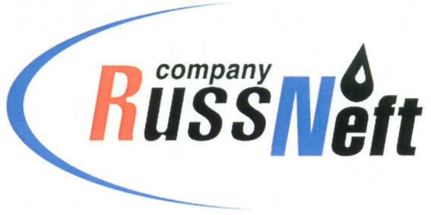

PJSC “RUSSNEFT” PRESS SERVICE

Tel.: (495) 411-63-24; (495) 411-63-21  Fax: (495) 411-63-19  E-mail: pr@russneft.ru  www.russneft.ru | 115054, Moscow,  Pyatnitskaya str., 69

PRESS RELEASE
July 25, 2022

PJSC "RussNeft” Replenishes the Ob-Irtysh Fishery Basin with Bioresources

PJSC “RussNeft” has replenished the Ob River basin with fish resources, releasing 397.5 thousand of peled small fry and 44.5 thousand nelma fry.
This is not the first experience of the Company. The release of small fry into the reservoir is carried out under the supervision of specialists from Tyumen branch of the All-Russian Research Institute of Fisheries and Oceanography. The volume of investments by PJSC “RussNeft” into stocking of fish the Ob-Irtysh fishery basin in 2022 amounted to RUB 5.37 million.
The annual stocking of fish in the regions of oil production makes it possible to systematically restore aquatic biological resources affected during the development of deposits in Western Siberia. Measures for the artificial reproduction of aquatic biological resources were carried out by PJSC “RussNeft” as part of the implementation of projects to develop Tagrinskoye and Verkhne-Shapshinskoye fields.

About the Company:
PJSC “RussNeft” ranks among the top-10 largest oil companies by crude oil production in Russia.
The Company possesses a well-balanced portfolio of assets located in the key Russian oil and gas provinces (West Siberia, Volga-Urals and Central Siberia) as well as in Azerbaijan.
The headcount of the Company is around 8,000 employees.

PJSC “RussNeft” Press Service
Tel.: (495) 411-63-24, Fax: (495) 411-63-19
E-mail: pr@russneft.ru

