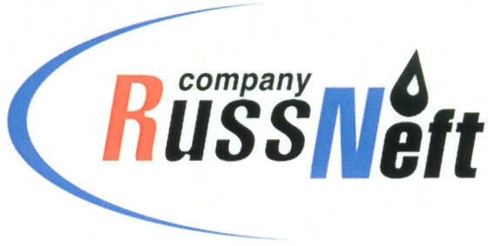
PJSC “RUSSNEFT”
PRESS SERVICE

Tel.: (495) 411-63-24; (495) 411-63-21  Fax: (495) 411-63-19  E-mail: pr@russneft.ru  www.russneft.ru | 115054, Moscow,  Pyatnitskaya str., 69

PRESS - RELEASE
August 29, 2023
RussNeft participates in “Help to Get Ready for School” campaign

The Ulyanovsk branch of PJSC “RussNeft” has provided charitable funds to help children from low-income families in preparations for the new school year.
This time, the annual campaign "Help to Get Ready for School" will cover children living in the Novomalyklinsky district of the Ulyanovsk region. With funds allocated by the Company, sets of school and sports clothing, student backpacks and stationery were purchased.
The charity campaign "Help to Get Ready for School" has been held in the Ulyanovsk region since 2005 and is aimed at targeted social assistance to school-age children from large and low-income families, families in difficult life circumstances.
The Ulyanovsk branch of RussNeft strives to fully contribute to the development of the social sphere of the region, as well as to provide targeted support to people who have reached out.

About the Company:
PJSC “RussNeft” ranks among the top-10 largest oil companies by crude oil production in Russia.
The Company possesses a well-balanced portfolio of assets located in the key Russian oil and gas provinces (West Siberia, Volga-Urals and Central Siberia) as well as in Azerbaijan.
The headcount of the Company is around 8,000 employees.

Press Service of PJSC "RussNeft"
Phone: (495) 411-63-24
Fax: (495) 411-63-19
E-mail: pr@russneft.ru

