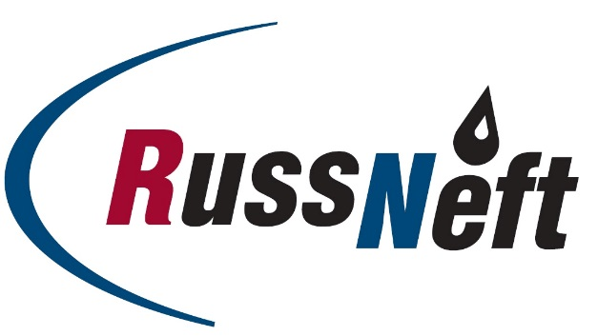
PJSC “RUSSNEFT” PRESS SERVICE

Tel.: (495) 411-63-24; (495) 411-63-21  Fax: (495) 411-63-19  E-mail: pr@russneft.ru  www.russneft.ru | 115054, Moscow,  Pyatnitskaya str., 69

PRESS RELEASE
February 26, 2019

RussNeft provided financial support to the competition of reindeer herders of Yugra

PJSC “RussNeft” became a partner of the V Contest of professional skills among reindeer herders of the Khanty-Mansiysk Autonomous District - Yugra.
OJSC MPK Aganneftegazgeologiya, a subsidiary of the Company, provided financial support in the organization of the competition and became the founder of special prizes.
The best Autonomous District reindeer herders from Berezovsky, Beloyarsk, Surgut, Nizhnevartovsk and Khanty-Mansiysk regions will take part in large-scale events under the auspices of the Governor of Yugra.
Aganneftegazgeologiya produces oil on the lands traditionally used by 56 families of low-numbered peoples of the North. Preservation of the culture, traditions and customs of the indigenous people of Yugra is one of the main directions of the Company's social projects.
Besides
About the Company:

PJSC “RussNeft” ranks among the Top-10 largest oil companies by crude oil production in Russia.
The Company possesses a well-balanced portfolio of assets located in the key Russian oil and gas provinces (West Siberia, Volga-Urals and Central Siberia) as well as in Azerbaijan.
The number of the Company’s personnel is around 10,000.

PJSC “RussNeft” Press Service
Tel.: (495) 411-63-24, Fax: (495) 411-63-19
E-mail: pr@russneft.ru

