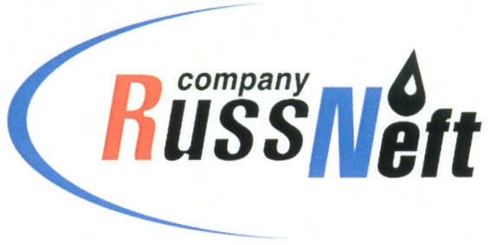
PJSC “RUSSNEFT”
PRESS SERVICE

Tel.: (495) 411-63-24; (495) 411-63-21  Fax: (495) 411-63-19  E-mail: pr@russneft.ru  www.russneft.ru | 115054, Moscow,  Pyatnitskaya str., 69

PRESS - RELEASE
November 17, 2022
RussNeft continues implementing charitable programmes in Nizhnevartovsk region of KhMAO

Nizhnevartovsk branch of PJSC “RussNeft” allocated 4.7 million rubles in 2022 for the implementation of regional charitable and sponsorship projects.
As part of the socio-economic agreement with the Raduzhny town administration, the Company supported the implementation of municipal programmes enhancing the material and technical basis of institutions of education, culture and art, sports, youth policy, as well as holding town mass events, the development of public space in the urban environment. The branch allocated 2.6 million rubles for these purposes.
With funding by RussNeft, celebrations dedicated to the Establishment Day of the Nizhnevartovsk district were held. 300 thousand rubles were assigned for the organization and holding of festive events.
Besides, the Company co-financed projects promoting the distinctive culture and traditional management of the indigenous peoples of the Khanty-Mansi Autonomous Okrug - Yugra. Sponsorship was provided to the Inter-Settlement Center of National Arts and Crafts (Agan village, Nizhnevartovsk district). RussNeft is a permanent partner and founder of the special prizes of vocational skill contest among reindeer herders for the Cup of the Governor of Ugra. The company took part in the implementation of the program entitled "Sustainable development of indigenous peoples of the North in the Nizhnevartovsk region". 700 thousand rubles were allocated to finance this area of social support.
In 2022, public organization of pensioners and veterans of Raduzhny, the Novoagansky district hospital, the "Yunost" sports school of Olympic reserve, city preschool and general education institutions and cultural institutions were provided with financial support.

About the Company:
PJSC “RussNeft” ranks among the top-10 largest oil companies by crude oil production in Russia.
The Company possesses a well-balanced portfolio of assets located in the key Russian oil and gas provinces (West Siberia, Volga-Urals and Central Siberia) as well as in Azerbaijan.
The headcount of the Company is around 8,000 employees.

Press Service of PJSC "RussNeft"
Phone: (495) 411-63-24
Fax: (495) 411-63-19
E-mail: pr@russneft.ru

