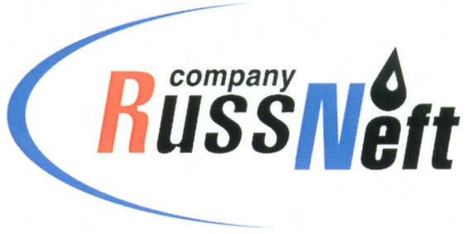
PJSC “RUSSNEFT”
PRESS SERVICE

Tel.: (495) 411-63-24; (495) 411-63-21  Fax: (495) 411-63-19  E-mail: pr@russneft.ru  www.russneft.ru | 115054, Moscow,  Pyatnitskaya str., 69

PRESS - RELEASE
September 26, 2023
Educational Infrastructure of Raduzhny Financed by PJSC “RussNeft“

In September, Nizhnevartovsk branch of PJSC “RussNeft” became part of charitable projects in the field of educational institutions in Raduzhny, Khanty-Mansi Autonomous Okrug.
In particular, the branch financed establishment of an art space at a secondary school in the city. The company also helped Snezhinka kindergarten to purchase necessary equipment.
Earlier PJSC “RussNeft” provided financial support for organizing celebrations in the settlement of Izluchinsk dedicated to the 95th Anniversary of Nizhnevartovsk region.
Today, the company continues to actively cooperate with municipal institutions and public organizations in order to implement socially significant and charitable projects in the regions where the company operates.
The social and economic partnership with the municipalities of the Khanty-Mansi Autonomous Okrug started in 2010.

About the Company:

PJSC “RussNeft” ranks among the top-10 largest oil companies by crude oil production in Russia.
The Company possesses a well-balanced portfolio of assets located in the key Russian oil and gas provinces (West Siberia, Volga-Urals and Central Siberia) as well as in Azerbaijan.
The headcount of the Company is around 8,000 employees.

Press Service of PJSC "RussNeft"
Phone: (495) 411-63-24
Fax: (495) 411-63-19
E-mail: pr@russneft.ru

