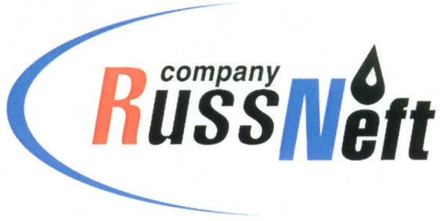
PJSC “RUSSNEFT” PRESS SERVICE

Tel.: (495) 411-63-24; (495) 411-63-21  Fax: (495) 411-63-19  E-mail: pr@russneft.ru  www.russneft.ru | 115054, Moscow,  Pyatnitskaya str., 69

PRESS - RELEASE
October 17, 2022
RussNeft's social programs were highly appreciated in Saratov

The Saratov branch of PJSC “RussNeft” became the winner of the regional stage of the All-Russia contest Russian Organization of High Social Performance. The company took first place in the For the Contribution of Social Investments and Charity to the Development of Territories category.
The contest has been held annually since 2000, and its priorities are attracting public attention to the importance of tackling social issues at the entity`s level, identifying the best social projects, creating a positive social image. The award to the Saratov branch was the result of the implementation of the Company's charity program in the territories of its presence.
A special place in the Company's charity program in the Saratov region is occupied by joint projects with Rovesnik children's wellness center. For instance, in 2021, 1000 schoolchildren and students became participants of sensitization, educational, cultural, sports programs, in 2022 that number grew to 1100.

About the Company:
PJSC “RussNeft” ranks among the top-10 largest oil companies by crude oil production in Russia.
The Company possesses a well-balanced portfolio of assets located in the key Russian oil and gas provinces (West Siberia, Volga-Urals and Central Siberia) as well as in Azerbaijan.
The headcount of the Company is around 8,000 employees.

Press Service of PJSC "RussNeft"
Phone: (495) 411-63-24
Fax: (495) 411-63-19
E-mail: pr@russneft.ru

