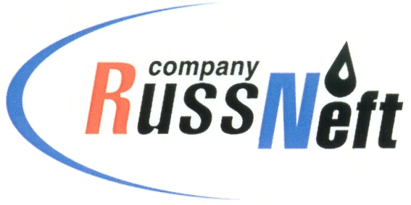
PJSC “RUSSNEFT” PRESS SERVICE

Tel.: (495) 411-63-24; (495) 411-63-21  Fax: (495) 411-63-19  E-mail: pr@russneft.ru  www.russneft.ru | 115054, Moscow,  Pyatnitskaya str., 69

PRESS-RELEASE

May 11, 2018

“RussNeft” Management intends to recommend the Board of Directors pay dividends on the preferred shares in amount of $40 million

Management of PJSC “RussNeft” prepared a proposal for the Board of Directors of the Company to pay dividends based on the Company’s performance in 2017.

According to the Management, the operational-financial indicators of “RussNeft” in the reporting year allow to allocate $40 million for payment of the dividends on the preferred shares.

Therefore, “RussNeft” demonstrates adherence to the previously declared dividend policy of the Company.

Decision on the payment and size of the dividends will be made at the annual shareholders’ meeting under the recommendation of the Board of Directors of the Company.

About the Company:
PJSC “RussNeft” ranks among the Top-10 largest oil companies by crude oil production in Russia.
The Company possesses a well-balanced portfolio of assets located in the key Russian oil and gas provinces (West Siberia, Volga-Urals and Central Siberia) as well as in Azerbaijan.
The company’s 2P reserves are over 200 million tonnes (SPE).
The number of the Company’s personnel is around 10,000.

PJSC “RussNeft” Press Service
Tel.: (495) 411-63-24, Fax: (495) 411-63-19
E-mail: pr@russneft.ru

