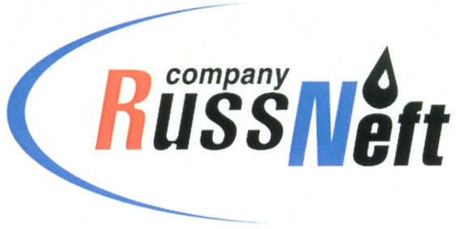
PJSC “RUSSNEFT” PRESS SERVICE

Tel.: (495) 411-63-24; (495) 411-63-21  Fax: (495) 411-63-19  E-mail: pr@russneft.ru  www.russneft.ru | 115054, Moscow,  Pyatnitskaya str., 69

PRESS RELEASE
September 22, 2021

Economic benefit of RussNeft from innovation in drilling technology
amounts to RUB 1.1 bln in 2021

PJSC “RussNeft” is planning to obtain the total economic effect from the introduction of the two-column well construction technology in the amount of RUB 1.1bln in 2021. The essence of the technological innovation is the transition from wells with a 168 mm- diameter production string and a 114 mm shank end, to a structure with one combined production string of 146x114 mm.
The savings are achieved via:
- shortening of the construction cycle by 5 days (by reducing the number and duration of non-meter operations);
- reducing steel intensity (by reducing the diameters of production columns);
- reducing the volume of drilled rock and the costs of its decontamination and treatment (by reducing the diameters of the bore bits);
- consistency in equipment the drilling rigs for over 4300 meters boreholes (by reducing the steel intensity and the use of combined drilling tools);
- exclusion of the use of rotary steerable systems for drilling horizontal sections of more than 1300 meters (through the innovative designs of drilling tools and bottom hole assembly);
- shifting from the hydrocarbon drilling mud to the water-based drilling mud (due to the introduction of innovative formulations and reducing the cost of hazardous waste disposal);
- maintaining the minimum preparation of the well pad (due to the use of modernized drilling rigs of the BU-3000EUK type and without the use of heavier machines).
The total reduction in the average cost of wells due to the use of these technological solutions amounted to more than 20% of the total costs for drilling with "168x114" production string arrangement.

About the Company:

PJSC “RussNeft” ranks among the top-10 largest oil companies by crude oil production in Russia.
The Company possesses a well-balanced portfolio of assets located in the key Russian oil and gas provinces (West Siberia, Volga-Urals and Central Siberia) as well as in Azerbaijan.
The Company's 2P reserves exceed 200 million tonnes (SPE). The headcount of the Company is around 8,000 employees.

PJSC “RussNeft” Press Service
Tel.: (495) 411-63-24, Fax: (495) 411-63-19
E-mail: pr@russneft.ru

