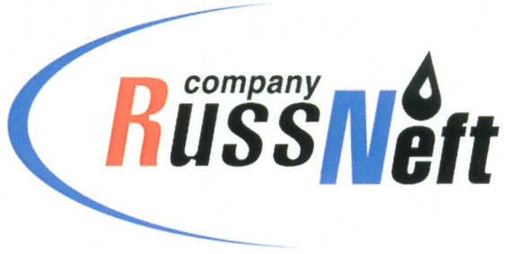
PJSC “RUSSNEFT”
PRESS SERVICE

Tel.: (495) 411-63-24; (495) 411-63-21  Fax: (495) 411-63-19  E-mail: pr@russneft.ru  www.russneft.ru | 115054, Moscow,  Pyatnitskaya str., 69

PRESS - RELEASE
January 29, 2024
RussNeft continues to implement training programs for its employees

RussNeft successfully continues to implement skills conversion training and advanced training program for the Company’s employees in its Saratov branch.
At the end of 2023, 1,362 RussNeft specialists performed skills conversion retraining at Saratovnedra training center, established on the basis of Saratovneftegaz back in 1950. The center offers 120 popular programs for advanced training of employees of the largest enterprises in Saratov region, incl. PJSC Saratov Oil Refinery, PJSC Saratovnefteproduct, LLC Gazprom UGS, LLC Yukola Neft, LLC Diall Alliance, directorates of PJSC Russian Railways in Saratov region, PJSC Rostelecom, PJSC Rosseti. Last year the total number of the participants reached 9,400 people. Saratovnedra training center has been verified for compliance with legal requirements by the Ministry of Labor and Social Protection of the Russian Federation.
RussNeft annually implements programs to improve the educational level of employees in the regions of its presence, as well as in the country's leading universities, including Lomonosov Moscow State University.

About the Company:

PJSC “RussNeft” ranks among the top-10 largest oil companies by crude oil production in Russia.
The Company possesses a well-balanced portfolio of assets located in the key Russian oil and gas provinces (West Siberia, Volga-Urals and Central Siberia) as well as in Azerbaijan.
The headcount of the Company is around 8,000 employees.

Press Service of PJSC "RussNeft"
Phone: (495) 411-63-24
Fax: (495) 411-63-19
E-mail: pr@russneft.ru

