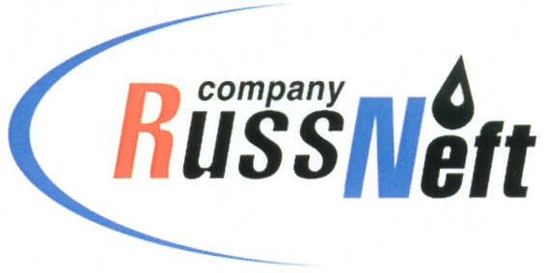
PJSC “RUSSNEFT”
PRESS SERVICE

Tel.: (495) 411-63-24; (495) 411-63-21  Fax: (495) 411-63-19  E-mail: pr@russneft.ru  www.russneft.ru | 115054, Moscow,  Pyatnitskaya str., 69

PRESS - RELEASE
April 16, 2021
"RussNeft" continues to implement the charitable project "We are the Children of Space!" in Rovesnik

PJSC "RussNeft" continues to implement the charitable project "We are the Children of Space!" on the basis of the children's health center "Rovesnik".
In the year of the 60th anniversary of the First Man of the Earth Yuri Gagarin flight into space, 130 schoolchildren from Saratov region districts and students of the vocational-pedagogical college of the Saratov State Technical University named after Y.A. Gagarin took part in the project. In just 6 years of the project's implementation, more than 1,500 boys and girls took part in it, passionate about technology and creativity, the theme of space.
The programme of the project this year traditionally included a range of educational, sports and entertainment and creative events: talent shows, sports festivals, flash mobs, quizzes, hobby groups, evening bonfires and discos. But the main event of the project was a meeting with famous people, whose activities are connected with the conquest of the sky: astronauts, test pilots, scientists and inventors. Among the guests of honour in 2021 are Hero of the Soviet Union, Cosmonaut A.N. Balandin, Hero of the Russian Federation, Deputy Head of the Yuri Gagarin Cosmonaut Training Centre V.A. Ren, Vice-President of the Russian Parachuting Federation, Honoured Coach of Russia M.A. Potapov.
In addition to being informative and entertaining, the project aims to educate children and young people about patriotism.

About the Company:Abocompany:
PJSC “RussNeft” ranks among the top-10 largest oil companies by crude oil production in Russia.
The Company possesses a well-balanced portfolio of assets located in the key Russian oil and gas provinces (West Siberia, Volga-Urals and Central Siberia) as well as in Azerbaijan.
The Company's 2P reserves exceed 200 million tonnes (SPE). The headcount of the Company is around 9000 employees.

Press Service of PJSC "RussNeft"
Phone: (495) 411-63-24 Fax: (495) 411-63-19
E-mail: pr@russneft.ru

