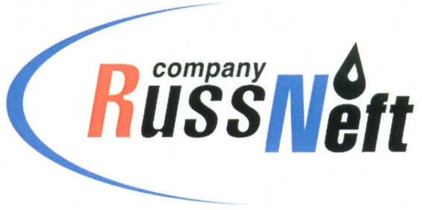

**PJSC “RUSSNEFT” PRESS SERVICE**

|  |  |
| --- | --- |
| **Tel.: (495) 411-63-24; (495) 411-63-21**  **Fax: (495) 411-63-19**  **E-mail: pr@russneft.ru**  **[www.russneft.ru](http://www.russneft.ru/)** | **115054, Moscow,**  **Pyatnitskaya str., 69** |

**PRESS - RELEASE**

**October 21, 2024**

**"RussNeft" has allocated over 24 million rubles for compensation payments to the indigenous peoples of the North**

PJSC "RussNeft" has allocated more than 24 million rubles this year for compensation payments to indigenous small-numbered peoples of the North, living at the Company's license areas in the Khanty-Mansiysk Autonomous Okrug (Yugra).

"RussNeft" produces hydrocarbons within the Nizhnevartovsk, Surgut, Khanty-Mansiysk, Nefteyugansk and Oktyabrsky districts of Yugra on lands belonging to 17 territories of traditional nature management of 70 families of indigenous peoples of the North.

In addition, this year "RussNeft" once again acted as a partner and founder of the special prizes of the competition of professional skills among reindeer herders of the district for the cup of the Governor of Ugra, provided financial support to the Inter-Municipal Center of National Crafts and targeted financial assistance to indigenous families in difficult life situations.

"RussNeft" continues to finance programs aimed at supporting and preserving the distinctive culture, traditions and customs of the indigenous population of Yugra.

**About the Company:**

PJSC “RussNeft” ranks among the top-10 largest oil companies by crude oil production in Russia.

The Company possesses a well-balanced portfolio of assets located in the key Russian oil and gas provinces (West Siberia, Volga-Urals and Central Siberia).

The headcount of the Company is around 7,000 employees.

**Press Service of PJSC "RussNeft"**

**Phone: (495) 411-63-24, Fax: (495) 411-63-19**

**E-mail:**[**pr@russneft.ru**](mailto:pr@russneft.ru)