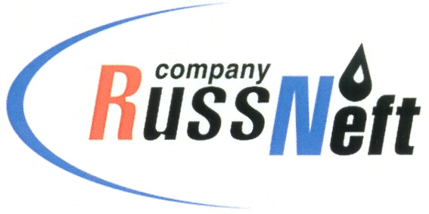
PJSC “RUSSNEFT”
PRESS SERVICE

Tel.: (495) 411-63-24; (495) 411-63-21  Fax: (495) 411-63-19  E-mail: pr@russneft.ru  www.russneft.ru | 115054, Moscow,  Pyatnitskaya str., 69

PRESS - RELEASE
March 10, 2021
RussNeft together with Gubkin University
continue educational programme implementation in regions

PJSC “RussNeft” together with Gubkin Russian State University of Oil and Gas continue to implement an educational programme to enhance the academic level of school students in the regions.
In the context of long lasting cooperation, the teachers of the University provide lessons at the Regional Preparatory Courses (RPC) in two field-specific subjects, Mathematics and Physics. This academic year, classes in the autumn and spring session were conducted in a distant form.
According to the University teachers, training at RPC provides additional opportunities for university applicants from towns and villages remote from regional centres to prepare for the Unified State Exam as effectively as possible and to matriculate to universities. All costs of pre-university training of the applicants were assumed by RussNeft.
The joint project with University is part of a charity programme of RussNeft and is aimed at improving the quality of schoolchildren knowledge in the regions of the Company`s operation.

About the Company:
PJSC “RussNeft” ranks among the top-10 largest oil companies by crude oil production in Russia.
The Company possesses a well-balanced portfolio of assets located in the key Russian oil and gas provinces (West Siberia, Volga-Urals and Central Siberia) as well as in Azerbaijan.
The headcount of the Company is around 10,000 employees.

Press Service of PJSC "RussNeft"
Phone: (495) 411-63-24 Fax: (495) 411-63-19
E-mail: pr@russneft.ru

