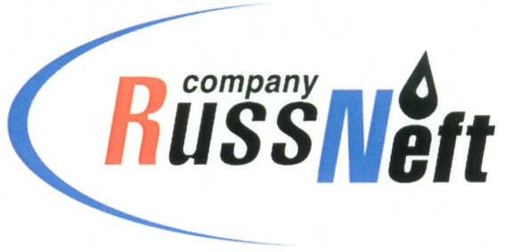
PJSC “RUSSNEFT” PRESS SERVICE

Tel.: (495) 411-63-24; (495) 411-63-21  Fax: (495) 411-63-19  E-mail: pr@russneft.ru  www.russneft.ru | 115054, Moscow,  Pyatnitskaya str., 69

PRESS RELEASE
June 22, 2020

RussNeft has allocated funds to repair the monument to the 75th anniversary of Victory

PJSC “RussNeft” has allocated funds to the 75th anniversary of Victory in the Great Patriotic War to repair the monument to the fallen heroes in Novomalyklinsk district of Ulyanovsk region.

The monument was established in 1965. Today, its pedestal needed serious reconstruction. All necessary works have been carried out to restore the monument to the heroes of the Great Victory with the funds allocated by the Company.

Ulyanovsk branch of "RussNeft" is in constant contact with the authorities and public of the region as part of its charitable activities in the regions of its presence and considers the preservation of the memory of the heroic deeds of the people who fought heroically on the fronts of the Great Patriotic War, sacrificed their lives for the independence of their country to be an integral part of its social activity, expressing them endless gratitude for their courage and bravery, steadfastness of spirit and devotion to the Motherland, for our peaceful and free life.

About the Company:

PJSC “RussNeft” ranks among the top-6 largest oil companies by crude oil production in Russia.
The Company possesses a well-balanced portfolio of assets located in the key Russian oil and gas provinces (West Siberia, Volga-Urals and Central Siberia) as well as in Azerbaijan.
The headcount of the Company is around 10,000 employees.

PJSC “RussNeft” Press Service
Tel.: (495) 411-63-24, Fax: (495) 411-63-19
E-mail: pr@russneft.ru

