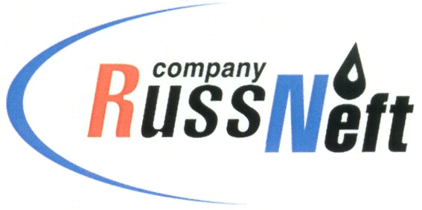
PJSC “RUSSNEFT” PRESS SERVICE

Tel.: (495) 411-63-24; (495) 411-63-21  Fax: (495) 411-63-19  E-mail: pr@russneft.ru  www.russneft.ru | 115054, Moscow,  Pyatnitskaya str., 69

PRESS - RELEASE
August 12, 2026

Young specialists of RussNeft’s Saratov branch master AI capabilities

Young specialists of the Saratov branch of PJSC “RussNeft” are mastering the capabilities of artificial intelligence (AI) for its efficient implementation into the Company's production operations.

At the first stage, members of the branch's Youth Council used AI to analyze the Company's local regulations and create a unified guide for beginner oilmen.

The annual scientific and technical conference of young specialists helps develop internal corporate initiatives. The platform serves to demonstrate developments aimed at improving the Holding's production processes, which is undoubtedly a unique opportunity for young specialists to prove themselves at the corporate level. Last year, young oilmen from the Saratov branch presented 10 projects to the competition committee for further implementation.

About the Company:

PJSC “RussNeft” ranks among the top-10 largest oil companies by crude oil production in Russia.

The Company possesses a well-balanced portfolio of assets located in the key Russian oil and gas provinces (West Siberia, Volga-Urals and Central Siberia).

The headcount of the Company is over 6,000 employees.

Press Service of PJSC "RussNeft"
Phone: (495) 411-63-24, Fax: (495) 411-63-19
E-mail: pr@russneft.ru

