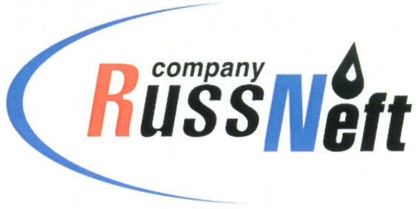

PJSC “RUSSNEFT” PRESS SERVICE

|  |  |
| --- | --- |
| **Tel.: (495) 411-63-24; (495) 411-63-21**  **Fax: (495) 411-63-19**  **E-mail: pr@russneft.ru**  [**www.russneft.ru**](http://www.russneft.ru/) | **115054, Moscow,**  **Pyatnitskaya str., 69** |

**PRESS RELEASE**

**March 20, 2020**

**“RussNeft” expands the use of pilotless aerial vehicles at Variogan block**

PJSC “RussNeft” commenced active use of helicopter-type pilotless aerial vehicles at the oilfields of Variogan oil block.

Drones allow to solve logistical problems on the field, as the drones can easily run at an altitude of up to 0.5 km, automatically detecting and bypassing obstacles. Under unfavorable weather conditions the drone is more effective than satellites due to higher resolution when taking photos.

In addition, the use of the drone provides an additional opportunity for monitoring the operation of industrial facilities.

The first drones began to be used to support surveying in the oilfields development of the Varyogan oil block back in 2018.

The main objectives of the use of drones remain: operational monitoring of the implementation of construction and installation works,

control over timber felling, inspection of oil-contaminated hard-to-reach areas, providing photo and video materials to the regional forestry departments for the purposes of the forest areas reinstatement acceptance, as well as performing aerial photography to create digital orthophotoplans, which will allow creating and using updated digital cartographic materials to address operations issues.

**About the Company:**

PJSC “RussNeft” ranks among the top-6 largest oil companies by crude oil production in Russia.

The Company possesses a well-balanced portfolio of assets located in the key Russian oil and gas provinces (West Siberia, Volga-Urals and Central Siberia) as well as in Azerbaijan.

The headcount of the Company is around 10,000 employees.

**PJSC “RussNeft” Press Service**

**Tel.: (495) 411-63-24, Fax: (495) 411-63-19**

**E-mail: pr@russneft.ru**