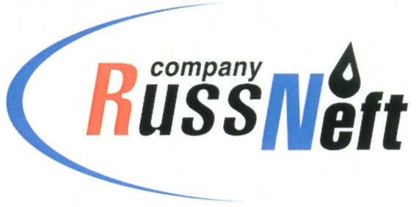
PJSC “RUSSNEFT” PRESS SERVICE

Tel.: (495) 411-63-24; (495) 411-63-21  Fax: (495) 411-63-19  E-mail: pr@russneft.ru  www.russneft.ru | 115054, Moscow,  Pyatnitskaya str., 69

PRESS RELEASE
July 14, 2020

The economic effect of innovations has exceeded 259 million rubles

PJSC “RussNeft” assessed the economic effect of the program for optimization of production processes in 2019 in the amount of 259 million rubles.

The figures of economic efficiency from the implementation of scientific and technical ideas are growing from year to year: the effect amounted to 165 million rubles in 2017 and 207 million rubles in 2018.

In 2020, several hundreds of innovations proposed by RussNeft subsidiaries and branches were submitted for consideration by the Company's Scientific and Technical Council chaired by the Company's President Evgeny Tolochek. 80 out of the total number of projects were accepted for consideration.

The program for accumulating advanced scientific and technical ideas of the Company's employees started in 2017 and became the basis for RussNeft annual corporate contest. According to the results of the contest "Team of the year for optimization of production costs 2020" Khanty-Mansiysk branch kept the first place, Varioganneft team took the second place and Ulyanovsk branch of RussNeft was the third.

About the Company:

PJSC “RussNeft” ranks among the top-10 largest oil companies by crude oil production in Russia.
The Company possesses a well-balanced portfolio of assets located in the key Russian oil and gas provinces (West Siberia, Volga-Urals and Central Siberia) as well as in Azerbaijan.
The Company's 2P reserves exceed 200 million tonnes (SPE). The headcount of the Company is around 10,000 employees.

PJSC “RussNeft” Press Service
Tel.: (495) 411-63-24, Fax: (495) 411-63-19
E-mail: pr@russneft.ru

