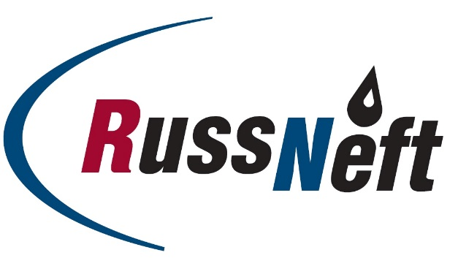
PJSC “RUSSNEFT” PRESS SERVICE

Tel.: (495) 411-63-24; (495) 411-63-21  Fax: (495) 411-63-19  E-mail: pr@russneft.ru  www.russneft.ru | 115054, Moscow,  Pyatnitskaya str., 69

PRESS RELEASE
January 21, 2020

A 15 mln tons Increment to RussNeft Reserves

Increment of PJSC “RussNeft” included into SAFMAR Group, reached 15 mln tons of oil in 2019.
In the reporting year the major scope of geological and exploration works was performed in Khanty-Mansi Autonomous Region.
The increment of reserves was the result of implementation of the geological and exploration program with hard-to-recover reserves staying the key constituent for the portfolio mid-term improvement.
The results of exploration drilling program confirmed high efficiency of the performed geological and exploration works. Thus 2019 showed 1.6 mln tons of oil and 13.3 mln tons of oil increment at Verkhne-Shapshinskoye (Achimov deposits) and Tagrinskoye field accordingly.
In the reporting year the geological survey of Khanty-Mansi field involved CPP 2P data (2 781 running km) processing and interpretation, which allowed to determine the area for further survey and performing of the detailed СРР 3D (100 sq. km area) at Palaeozoic deposits.

About the Company:
PJSC “RussNeft” ranks among the Top-10 largest oil companies by crude oil production in Russia.
The Company possesses a well-balanced portfolio of assets located in the key Russian oil and gas provinces (West Siberia, Volga-Urals and Central Siberia) as well as in Azerbaijan.
The number of the Company’s personnel is around 10,000.

PJSC “RussNeft” Press Service
Tel.: (495) 411-63-24, Fax: (495) 411-63-19
E-mail: pr@russneft.ru

