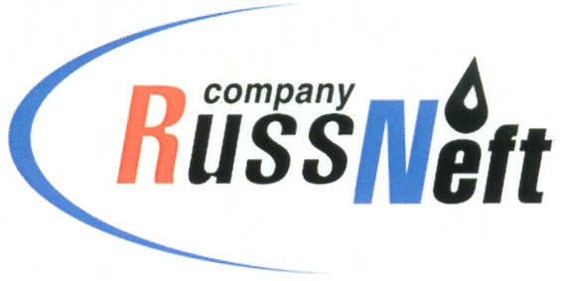
PJSC “RUSSNEFT”
PRESS SERVICE

Tel.: (495) 411-63-24; (495) 411-63-21  Fax: (495) 411-63-19  E-mail: pr@russneft.ru  www.russneft.ru | 115054, Moscow,  Pyatnitskaya str., 69

PRESS - RELEASE
April 20, 2021
RussNeft completed liquidation of sludge pits at the licenses of Khanty-Mansi Branch

PJSC “RussNeft” liquidated all sludge pits at the licenses of Khanty-Mansi Branch while implementing of environmental program activities.
The works on liquidation of drilling mud handling facilities at the Branch’s production sites were performed in several stages: 23 sludge pits were liquidated in 2019 (expenses made up 535 mln RUB.), the rest 2 of them were liquidated in 2020.
Nowadays the reclaimed lands are seeded with grass and trees. No new sludge pits are planned, which fully excludes further accumulation of drilling mud.
RussNeft focuses on compliance with the environmental laws and preventing negative influence of production on environment.

About the Company:Abocompany:
PJSC “RussNeft” ranks among the top-6 largest oil companies by crude oil production in Russia.
The Company possesses a well-balanced portfolio of assets located in the key Russian oil and gas provinces (West Siberia, Volga-Urals and Central Siberia) as well as in Azerbaijan.
The Company's 2P reserves exceed 200 million tonnes (SPE). The headcount of the Company is around 9, 000 employees.

Press Service of PJSC "RussNeft"
Phone: (495) 411-63-24 Fax: (495) 411-63-19
E-mail: pr@russneft.ru

