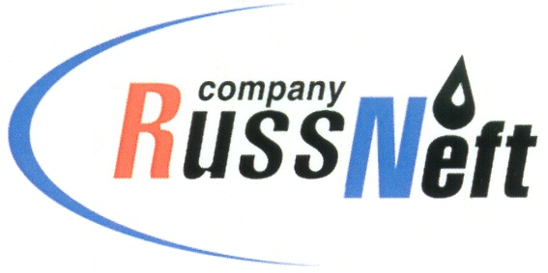
PJSC “RUSSNEFT” PRESS SERVICE

Tel.: (495) 411-63-24; (495) 411-63-21  Fax: (495) 411-63-19  E-mail: pr@russneft.ru  www.russneft.ru | 115054, Moscow,  Pyatnitskaya str., 69

PRESS RELEASE
May 7, 2020

RussNeft helped restore a monument of military glory in Ulyanovsk region

PJSC "RussNeft" has allocated charitable funds to restore the monument to the fallen soldiers in the Great Patriotic War in Ulyanovsk region.

The obelisk of glory was established in 1965 and was in unsatisfactory condition. In preparation for the celebration of the 75th anniversary of Victory Day, the Ulyanovsk branch of the Company decided to finance a full replacement of the monument to fallen soldiers in the village of Stantsiya Yakushka of Novomalyklinsk district of the Ulyanovsk region.

In addition, the Ulyanovsk branch has allocated steel structures to protect the territory of the monument to soldiers of the Great Patriotic War in the village of Nikolskoye-on-Cheremshan of Melekessky district of Ulyanovsk region.

Ninety four veterans of Saratov Region received gifts from the Company's branch on the eve of the Victory Day.

About the Company:

PJSC “RussNeft” ranks among the top-10 largest oil companies by crude oil production in Russia.
The Company possesses a well-balanced portfolio of assets located in the key Russian oil and gas provinces (West Siberia, Volga-Urals and Central Siberia) as well as in Azerbaijan.
The headcount of the Company is around 10,000 employees.

PJSC “RussNeft” Press Service
Tel.: (495) 411-63-24, Fax: (495) 411-63-19
E-mail: pr@russneft.ru

