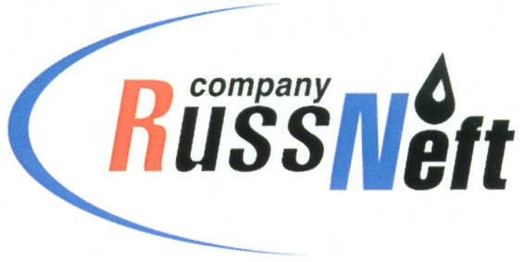
PJSC “RUSSNEFT” PRESS SERVICE

Tel.: (495) 411-63-24; (495) 411-63-21  Fax: (495) 411-63-19  E-mail: pr@russneft.ru  www.russneft.ru | 115054, Moscow,  Pyatnitskaya str., 69

PRESS RELEASE
May 29, 2020

RussNeft continues the environmental program at Variogan Block

PJSC "RussNeft" continues to work on the reclamation of oil-contaminated land at the fields of the Variogan oil block.
Thus, the subsidiary Varioganneft disposed of 6.49 thousand tons of oil sludge in the first four months of this year. To reduce the risk of pipeline incidents, the company constantly works to protect pipelines from non-categorical failures using a range of measures.
RussNeft pays great attention to environmental monitoring within the boundaries of its license areas. Studies of surface and underground water, bottom sediments, atmospheric air, snow cover and soil are carried out by specialists of own accredited laboratory for environmental protection and engaged organizations that specialize in providing services in the field of environmental monitoring.

About the Company:

PJSC “RussNeft” ranks among the top-6 largest oil companies by crude oil production in Russia.
The Company possesses a well-balanced portfolio of assets located in the key Russian oil and gas provinces (West Siberia, Volga-Urals and Central Siberia) as well as in Azerbaijan.
The headcount of the Company is around 10,000 employees.

PJSC “RussNeft” Press Service
Tel.: (495) 411-63-24, Fax: (495) 411-63-19
E-mail: pr@russneft.ru

