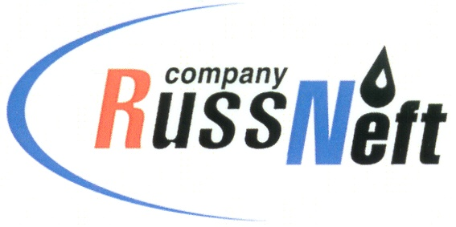
PJSC “RUSSNEFT” PRESS SERVICE

Tel.: (495) 411-63-24; (495) 411-63-21  Fax: (495) 411-63-19  E-mail: pr@russneft.ru  www.russneft.ru | 115054, Moscow,  Pyatnitskaya str., 69

PRESS RELEASE
February 17, 2026

RussNeft Expands Cooperation with the Blood Service

The Young Professionals Council of the Khanty-Mansiysk branch of PJSC “RussNeft” has proposed holding a blood donation drive every three months.
The branch is confident that working with the Blood Service should be organized on an ongoing basis: more and more Company employees are joining the effort.
Last summer, the Khanty-Mansiysk branch decided to become a corporate participant in Donor Day.
The Blood Service, in turn, notes that corporate participation in blood donation drives is crucial for the stable operation of medical institutions. Regular visits and scheduled events allow for the accumulation of blood and blood components in advance. Importantly, collaboration with businesses is becoming systemic.

About the Company:

PJSC “RussNeft” ranks among the top-10 largest oil companies by crude oil production in Russia.
The Company possesses a well-balanced portfolio of assets located in the key Russian oil and gas provinces (West Siberia, Volga-Urals and Central Siberia).
The headcount of the Company is around 6,000 employees.

PJSC “RussNeft” Press Service
Tel.: (495) 411-63-24,
Fax: (495) 411-63-19
E-mail: pr@russneft.ru

