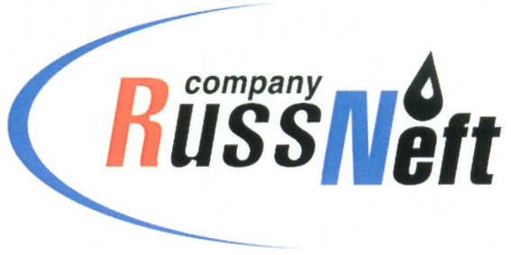
PJSC “RUSSNEFT” PRESS SERVICE

Tel.: (495) 411-63-24; (495) 411-63-21  Fax: (495) 411-63-19  E-mail: pr@russneft.ru  www.russneft.ru | 115054, Moscow,  Pyatnitskaya str., 69

PRESS RELEASE
August 5, 2019

FC Neftyanik has again become the leader of the mini-football inter-regional competitions

The team of girls of the sponsored FC Neftyanik (Novospasskoye village, Ulyanovsk region) took the first place at the all-Russian mini-football tournament "Champions League 2019".

The victory in the age group of girls born in 2006 was disputed by teams from Orenburg, Moscow, Gorokhovets, and Tuapse. Football players from Novospasskoye outplayed the opponents with only one draw and Svetlana Kulagina and Viktoria Taimenova from Neftyanik were recognized the best players of the tournament.

In July, the youngest trainees of the club (boys born in 2010-2011) took the first place at the Interregional festival of mini-football JUNIOR CUP in Ulyanovsk. For young players it was the first representative tournament which was attended by teams from Mordovia, Samara, and Saratov. With the support of fans and parents, the guys beat all their peers and took the first place. Maxim Yurzin from FC Neftyanik was recognized the best defender of the tournament, and Ivan Nadezhdin, trainee of the Novospassky club, was the best scorer having scored 5 goals.

In addition, the first round of the championship of Ulyanovsk region in football finished in July. According to its results, the adult team of Neftyanik surely occupies the leading position in the tournament grid.

About the Company:

PJSC “RussNeft” ranks among the top-10 largest oil companies by crude oil production in Russia.

The Company possesses a well-balanced portfolio of assets located in the key Russian oil and gas provinces (West Siberia, Volga-Urals and Central Siberia) as well as in Azerbaijan.

The headcount of the Company is around 10,000 employees.

PJSC “RussNeft” Press Service
Tel.: (495) 411-63-24, Fax: (495) 411-63-19
E-mail: pr@russneft.ru

