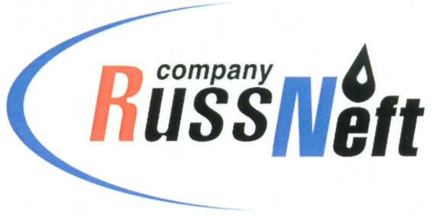
PJSC “RUSSNEFT” PRESS SERVICE

Tel.: (495) 411-63-24; (495) 411-63-21  Fax: (495) 411-63-19  E-mail: pr@russneft.ru  www.russneft.ru | 115054, Moscow,  Pyatnitskaya str., 69

PRESS RELEASE
October 10, 2019

Elderly people rest in Saratov`s Rovesnik

PJSC "RussNeft" is continuing to implement its traditional charity projects in the Saratov Region.
On the occasion of the International Day of Older People, the RussNeft` subsidiary Saratovneftegaz together with the regional Ministry of Social Development held "Silver Age" charity event for the sixth time: more than 100 elderly people from Saratov and municipal districts of the region were given the opportunity to have a three-days rest in the popular health center "Rovesnik".
There were many veterans of Saratovneftegaz among vacationers – those who not only made a significant contribution to the formation and development of one of the major oil and gas enterprises of the Volga region, but also was directly involved into the construction of the Rovesnik children's camp in the mid-80s of the last century. The organizers have prepared busy cultural programme for veterans, involving the Drama, Music and Poetry Theater Balaganchik. Besides, to mark the 100th anniversary of M.T. Kalashnikov`s birth, the veterans competed in laser tag. Family couples living together for 50 or more years were honored as part of the "Formula for Family Happiness" event.
Lately Rovesnik acquired deserved reputation of a cultural center: on its basis, at the expense of charity budget of PJSC "RussNeft", its Saratovneftegaz subsidiary, as well as the Charitable Foundation SAFMAR, many events of regional, interregional and international scope are held.

About Company:

PJSC "RussNeft" is among the top 10 largest oil companies in terms of oil production in Russia.
The company has a balanced portfolio of assets in Russia in key oil and gas regions (Western Siberia, Volga-Ural region and Central Siberia), as well as in Azerbaijan.
The number of employees of the Company is about 10 000 people.

Press-service of PJSC "RussNeft»
Tel: (495) 411-63-24, Fax: (495) 411-63-19

