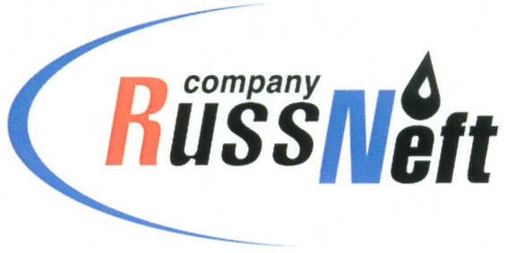
PJSC “RUSSNEFT” PRESS SERVICE

Tel.: (495) 411-63-24; (495) 411-63-21  Fax: (495) 411-63-19  E-mail: pr@russneft.ru  www.russneft.ru | 115054, Moscow,  Pyatnitskaya str., 69

PRESS - RELEASE
May 5, 2022
RussNeft continues implementing charity initiatives in Saratov

In April, an educational intensive course the Volunteers of Science was held on the basis of the Rovesnik Children's Wellness Center of Saratov.
The new educational project is a joint program between the Saratov branch of RussNeft, the Yuri Gagarin State Technical
University of Saratov and the regional branch of the All–Russian Society of Inventors and Innovators. The aim of the initiative was to develop creative thinking and research skills among young participants of the project.
The charity intensive course brought together the best middle classes students of the region. Under the guidance of qualified tutors, the children shared ideas, most of which are environment-related or are closely linked to the digitalization of scientific ideas. The unique method of classes, a combination of theory and practice, game moments and a scientific approach to problem solving have truly got the young inventors interested and allowed to achieve significant results.
The Volunteers of Science program is a logical continuation of a number of RussNeft educational projects aimed at the intellectual and creative development of the younger generation of the Saratov region.

About the Company:
PJSC “RussNeft” ranks among the top-10 largest oil companies by crude oil production in Russia.
The Company possesses a well-balanced portfolio of assets located in the key Russian oil and gas provinces (West Siberia, Volga-Urals and Central Siberia) as well as in Azerbaijan.
The headcount of the Company is around 8,000 employees.

Press Service of PJSC "RussNeft"
Phone: (495) 411-63-24
Fax: (495) 411-63-19
E-mail: pr@russneft.ru

