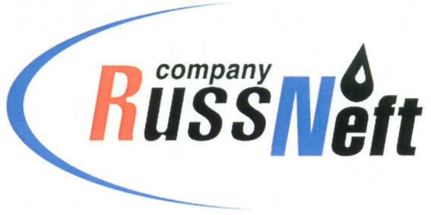
PJSC “RUSSNEFT”
PRESS SERVICE

Tel.: (495) 411-63-24; (495) 411-63-21  Fax: (495) 411-63-19  E-mail: pr@russneft.ru  www.russneft.ru | 115054, Moscow,  Pyatnitskaya str., 69

PRESS - RELEASE
June 29, 2021
“RussNeft” shareholders approved dividends on preferred shares in the amount of $ 60 million

The Annual General Meeting of PJSC “RussNeft” shareholders, held in absentee form on 28 June, approved the Company's Annual Report and Financial Statements for 2020.
The shareholders at the Annual Meeting set the number of members of the Board of Directors at twelve (12) and elected its new members, which included: Andrey Zarubin, Dmitry Romanov, Andrey Derekh, Viktor Martynov, Robert Skidelsky, Sergey Stepashin, Yana Tikhonova, Ann Nash, Roman Tyan, Anton Zhuchenko, Vyacheslav Marchenko and Sergey Chernyshev.
In addition, shareholders resolved to pay dividends on preferred shares in the amount of $0.6 per share for the reporting year (at the exchange rate of the Bank of Russia on the date of actual dividend payment).
The Annual Meeting approved OOO Interkom-Audit as RussNeft's auditor for accounting (financial) statements (RAS) in 2021 and OOO Ernst and Young for consolidated financial statements (IFRS) in 2021.

About the Company:Abocompany:
PJSC “RussNeft” ranks among the top-10 largest oil companies by crude oil production in Russia.
The Company possesses a well-balanced portfolio of assets located in the key Russian oil and gas provinces (West Siberia, Volga-Urals and Central Siberia) as well as in Azerbaijan.
The Company's 2P reserves exceed 200 million tonnes (SPE). The headcount of the Company is around 9000 employees.

Press Service of PJSC "RussNeft"
Phone: (495) 411-63-24 Fax: (495) 411-63-19
E-mail: pr@russneft.ru

