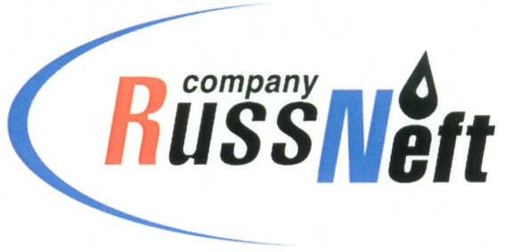

**PJSC “RUSSNEFT” PRESS SERVICE**

|  |  |
| --- | --- |
| **Tel.: (495) 411-63-24; (495) 411-63-21**  **Fax: (495) 411-63-19**  **E-mail: pr@russneft.ru**  [**www.russneft.ru**](http://www.russneft.ru/) | **115054, Moscow,**  **Pyatnitskaya str., 69** |

**PRESS RELEASE**

**April 29, 2025**

**RussNeft supports sports competitions for children with disabilities**

One hundred of the best athletes with disabilities from the Saratov region took part in the Spartakiad held under the patronage of PJSC “RussNeft”, SAFMAR Foundation, the Ministry of Labor and Social Protection of the Saratov Region and the regional children's and youth sports and adaptive school "Rehabilitation and Physical Education".

Competitions in athletics, bocce, darts, table tennis and other sports were held for teenagers from Atkarsk, Balashov, Balakov, Volsk, Yershov, Kalininsk, Krasnoarmeysk, Marx, Petrovsk, Pugachev, Rtishchev, Saratov, Khvalynsk and Engels at the Rovesnik Children's health center.

The bright performances and athletic skills of the Spartakiad participants were assessed by an experienced judging panel led by Svetlana Borisovskaya, Honored Coach of Russia, head of the Saratov branch of the Russian Paralympic Committee.

Currently, there are more than 7 thousand children with special developmental needs, living in the Saratov region. All of them require special attention and support.

**About the Company:**

PJSC “RussNeft” ranks among the top-10 largest oil companies by crude oil production in Russia.

The Company possesses a well-balanced portfolio of assets located in the key Russian oil and gas provinces (West Siberia, Volga-Urals and Central Siberia).

The headcount of the Company is around 7,000 employees.

**PJSC “RussNeft” Press Service**

**Tel.: (495) 411-63-24, Fax: (495) 411-63-19**

**E-mail: pr@russneft.ru**