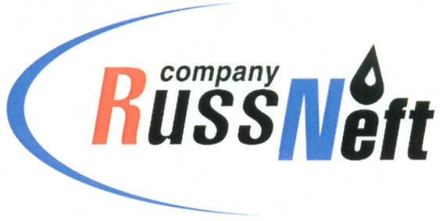
PJSC “RUSSNEFT” PRESS SERVICE

Tel.: (495) 411-63-24; (495) 411-63-21  Fax: (495) 411-63-19  E-mail: pr@russneft.ru  www.russneft.ru | 115054, Moscow,  Pyatnitskaya str., 69

PRESS RELEASE
May 24, 2019

RussNeft subsidiary signs mutual cooperation agreement with Raduzhny Town Administration

OAO Varioganneft, a subsidiary of PJSC “RussNeft”, has executed a cooperation agreement with Raduzhny Town Administration (Khanti-Mansiysky Autonomous District – Yugra).
The document was signed by the General Director of the entity Rustem Ilyasov and the Mayor of municipality Natalia Gulina.
The Agreement provides an example of long-term cooperation and focuses on social and economic development of the town and solving the community problems. Varioganneft enthusiastically supports municipal education, culture, sports, as well as institutions for disabled persons and war veterans. The enterprise provides charity aid to the faith-based organisations and socially vulnerable groups of citizens.
Varioganneft is one of the major taxpayers of the town. In 2018, the entity paid to the municipal budget over RUB 33 mln in taxes.

About the Company:
PJSC “RussNeft” ranks among the Top -10 largest oil companies by crude oil production in Russia.
The Company possesses a well-balanced portfolio of assets located in the key Russian oil and gas provinces (West Siberia, Volga-Urals and Central Siberia) as well as in Azerbaijan.
The number of the Company’s personnel is around 10,000.

PJSC “RussNeft” Press Service
Tel.: (495) 411-63-24, Fax: (495) 411-63-19
E-mail: pr@russneft.ru

