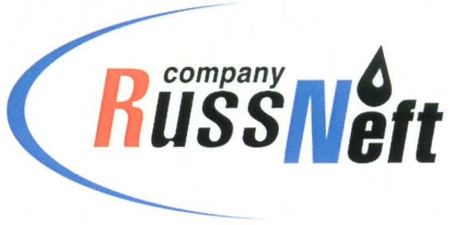

**PJSC “RUSSNEFT” PRESS SERVICE**

|  |  |
| --- | --- |
| **Tel.: (495) 411-63-24; (495) 411-63-21**  **Fax: (495) 411-63-19**  **E-mail: pr@russneft.ru**  [**www.russneft.ru**](http://www.russneft.ru/) | **115054, Moscow,**  **Pyatnitskaya str., 69** |

**PRESS - RELEASE**

**July 31, 2024**

**RussNeft determins winners of professional skills competition in Nizhnevartovsk branch**

Nizhnevartovsk branch of PJSC “RussNeft” summed up the results of the traditional professional skills competition Best in Profession. More than seventy representatives of the main blue-collar jobs of the enterprise participated in the contest in fifteen nominations.

The main objective of the event is to establish corporate labor standards based on the study and dissemination of best practices and workplace culture, encourage employee interest in improving professional skills, develop creative activity, enhance production efficiency and quality.

The program of the competition included two stages: theoretical and practical. At the theoretical stage, the participants of professional competitions showed knowledge of the fundamentals of the production process, labor protection and industrial safety. At the practical stage, the commission assessed the expertise and professional skills of applicants when performing work at production facilities.

The winners of the competition were awarded the "The Best in Profession" title and an annual salary supplement for professional skills and high qualifications.

**About the Company:**

PJSC “RussNeft” ranks among the top-10 largest oil companies by crude oil production in Russia.

The Company possesses a well-balanced portfolio of assets located in the key Russian oil and gas provinces (West Siberia, Volga-Urals and Central Siberia).

The headcount of the Company is around 7,000 employees.

**Press Service of PJSC "RussNeft"**

**Phone: (495) 411-63-24, Fax: (495) 411-63-19**

**E-mail:**[**pr@russneft.ru**](mailto:pr@russneft.ru)