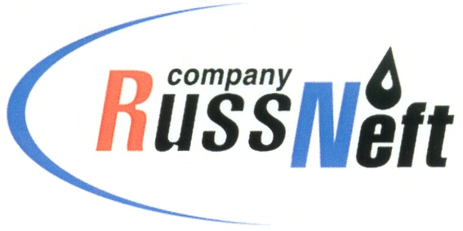
PJSC “RUSSNEFT” PRESS SERVICE

Tel.: (495) 411-63-24; (495) 411-63-21  Fax: (495) 411-63-19  E-mail: pr@russneft.ru  www.russneft.ru | 115054, Moscow,  Pyatnitskaya str., 69

PRESS RELEASE
August 28, 2020

PJSC “RussNeft” expands control over the quality of oil products

PJSC “RussNeft” uses new methods of oil products quality control.
Thus, the chemical and analytical laboratory of it’s subsidiary “Varioganneft” has expanded the range of measurements performed, as well as improved the accuracy and speed of research, thanks to the equipment re-equipment program which was launched several years ago.
The newest equipment makes it possible to determine various indicators of oil products quality at all stages of production and obtain necessary data to support the technological process of their production. The multistage quality control system, which covers all stages of oil products production, ensures its high performance. During the year, the Company's laboratory specialists conduct about 450 thousand tests of oil and oil products, including: detailed hydrocarbon analysis, determination of the micro-content of sulfur and sulfur-containing compounds, the content of the mass fraction of organochlorine compounds in oil, oxygenates, dienes, olefins, paraffins, and aromatic hydrocarbons.

About the Company:

PJSC “RussNeft” ranks among the top-10 largest oil companies by crude oil production in Russia.

The Company possesses a well-balanced portfolio of assets located in the key Russian oil and gas provinces (West Siberia, Volga-Urals and Central Siberia) as well as in Azerbaijan.

The headcount of the Company is around 10,000 employees.

PJSC “RussNeft” Press Service
Tel.: (495) 411-63-24, Fax: (495) 411-63-19
E-mail: pr@russneft.ru

