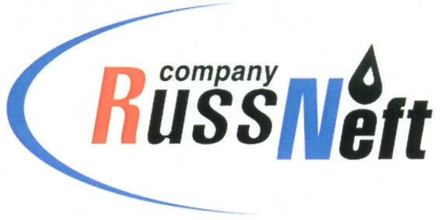
PJSC “RUSSNEFT” PRESS SERVICE

Tel.: (495) 411-63-24; (495) 411-63-21  Fax: (495) 411-63-19  E-mail: pr@russneft.ru  www.russneft.ru | 115054, Moscow,  Pyatnitskaya str., 69

PRESS RELEASE
August 30, 2021

RussNeft continues active cooperation with indigenous people of Ugra

Nizhnevartovsk branch of PJSC “RussNeft” supported the drive of residents of the national village Variogan, Nizhnevartovsk district on cleaning up the forest territories.
National village Variogan is a habitat of indigenous minorities of the North, namely the Khantys, Mansis, Forest Nenets.
Close to the village, there is an old burnt forest area. Now the forest cover is being rehabilitated at the site.
New trees have been planted, lichen and cowberry shrub have appeared. At the village assembly, residents decided to hold a community clean-up day and clear the territory, which became a popular spot for the wild crops gathering villagers, from burnt, fallen trees and upstanding dead trees. The Nizhnevartovsk branch of the company supported the initiative of local residents: employees of the branch took part in the clean-up day along with residents of the village and representatives of the rural administration. In addition, rough-terrain vehicles have been provided to deliver the participants of the event to the clearing site.
RussNeft conducts exploitation of hydrocarbons on the lands that belong to the territories of traditional nature use of more than 60 families of indigenous minorities of the North.
The preservation of the culture, traditions and customs of the indigenous people of Ugra is one of the priorities of the company's social projects implementation. The support of such initiatives of local residents serves as a good example of mutually beneficial cooperation between subsoil users and the indigenous population of Ugra.

About the Company:

PJSC “RussNeft” ranks among the top-10 largest oil companies by crude oil production in Russia.
The Company possesses a well-balanced portfolio of assets located in the key Russian oil and gas provinces (West Siberia, Volga-Urals and Central Siberia) as well as in Azerbaijan.
The Company's 2P reserves exceed 200 million tonnes (SPE). The headcount of the Company is around 8,000 employees.

PJSC “RussNeft” Press Service
Tel.: (495) 411-63-24, Fax: (495) 411-63-19
E-mail: pr@russneft.ru

