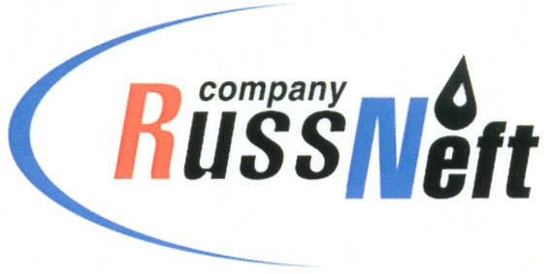

**PJSC “RUSSNEFT” PRESS SERVICE**

|  |  |
| --- | --- |
| **Tel.: (495) 411-63-24; (495) 411-63-21**  **Fax: (495) 411-63-19**  **E-mail: pr@russneft.ru**  [**www.russneft.ru**](http://www.russneft.ru/) | **115054, Moscow,**  **Pyatnitskaya str., 69** |

**PRESS RELEASE**

**July 23, 2024**

**FC Neftyanik successfully performed at the All-Russian football tournament**

Neftyanik football club, created under the patronage of PJSC “RussNeft”, successfully competed at the Summer Finist Cup 2024 All-Russian children's and youth football tournament in Tuapse.

The boys' team born in 2010-2011 won the tournament in a bitter struggle with their peers from other regions.

In addition, the mini-football School Sports League Open Championship in Syzran among boys born in 2012 and 2014 ended with great success for the FC trainees. Teams from Samara, Saratov and Ulyanovsk regions took part in the competition. Neftyanik trainees born in 2012 took 1st place; boys born in 2014 became silver medalists.

Neftyanik football club was created in 2003 in Novospasskoye industrial community of Novospassky district, Ulyanovsk region, with the support of RussNeft. From its inception to the present day, the company has provided patronage to the club. More than 200 children aged from 7 to 17 years are trained at Neftyanik. Today it is the only club in the region where training, sports equipment and participation in all competitions are free for the club’s trainees. Over the years of the FC's existence, young football players have become winners and prize-takers of regional, all-Russian and international tournaments.

**About the Company:**

PJSC "RussNeft" ranks among the top-10 largest oil companies by crude oil production in Russia.

The Company possesses a well-balanced portfolio of assets located in the key Russian oil and gas provinces (West Siberia, Volga-Urals and Central Siberia).

The headcount of the Company is around 7,000 employees.

**PJSC “RussNeft” Press Service**

**Tel.: (495) 411-63-24,**

**Fax: (495) 411-63-19**

**E-mail: pr@russneft.ru**