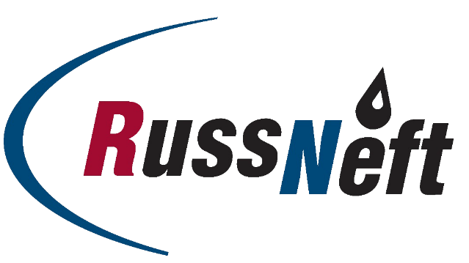

PJSC “RUSSNEFT” PRESS SERVICE

Tel.: (495) 411-63-24; (495) 411-63-21  Fax: (495) 411-63-19  E-mail: pr@russneft.ru  www.russneft.ru | 115054, Moscow,  Pyatnitskaya str., 69

PRESS - RELEASE
May 30, 2022
PJSC “RussNeft” continues its educational project with Lomonosov Moscow State University
The Graduate School of Innovative Business, a joint educational project of PJSC “RussNeft” and Lomonosov Moscow State University, awarded diplomas to the graduates of the 11th class (2020-2022) of MA students.
Since 2006, the faculty has trained more than 170 MA students who have joined the teams of the country's leading oil and gas companies.
The main objective of the Company's educational project is to fully promote educational programs for young people. The program of the Graduate School of Innovative Business includes a master's degree in natural resources management, environmental management, sustainable regional development and highly urbanized areas.

About the Company:
PJSC “RussNeft” ranks among the top-6 largest oil companies by crude oil production in Russia.
The Company possesses a well-balanced portfolio of assets located in the key Russian oil and gas provinces (West Siberia, Volga-Urals and Central Siberia) as well as in Azerbaijan.
The headcount of the Company is around 8,000 employees.

Press Service of PJSC "RussNeft"
Phone: (495) 411-63-24
Fax: (495) 411-63-19
E-mail: pr@russneft.ru

