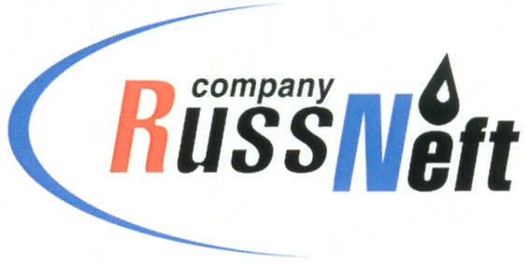
PJSC “RUSSNEFT”
PRESS SERVICE

Tel.: (495) 411-63-24; (495) 411-63-21  Fax: (495) 411-63-19  E-mail: pr@russneft.ru  www.russneft.ru | 115054, Moscow,  Pyatnitskaya str., 69

PRESS - RELEASE
April 16, 2024
RussNeft supports sporting competition for children with disabilities in Saratov

The Rovesnik Children's Health Center has held sports contest for children with disabilities under the patronage of PJSC “RussNeft”, SAFMAR Foundation, the Ministry of Labor and Social Protection of the Saratov region and the "Rehabilitation and Physical Education" regional children's and youth adaptive sports school.
The participants of the "Awards to the Strongest, Health to Everyone" sports contest are students of "Rehabilitation and Physical Education" sports school from 14 districts of the Saratov region. One hundred athletes represented the teams of the branches of the sports school from Saratov, Atkarsk, Balashov, Balakovo, Volsk, Ershov, Kalininsk, Krasnoarmeysk, Marx, Petrovsk, Pugachev, Rtishchevo, Khvalynsk, Engels.
The program of the sports contest included competitions in athletics, darts, swimming, table tennis and checkers. Throughout the competition, the young athletes actively supported each other, rooted for their team-mates, showed truly Olympic endurance, giving their all for victory.
Konstantin Lisenkov, two-time Paralympic Games champion in swimming, multiple champion and record holder of the world, Europe and Russia, and Malyak Aliyeva, silver medalist of Paralympic Games in table tennis, European champion, multiple champion of Russia, came to support the children. By tradition, all participants were awarded memorable gifts.
The competitive spirit, commitment to win, self–confidence and new friends - all these are the necessary elements of the event held.

About the Company:
PJSC “RussNeft” ranks among the top-10 largest oil companies by crude oil production in Russia.
The Company possesses a well-balanced portfolio of assets located in the key Russian oil and gas provinces (West Siberia, Volga-Urals and Central Siberia) as well as in Azerbaijan.
The headcount of the Company is around 7,000 employees.

Press Service of PJSC "RussNeft"
Phone: (495) 411-63-24
Fax: (495) 411-63-19
E-mail: pr@russneft.ru

