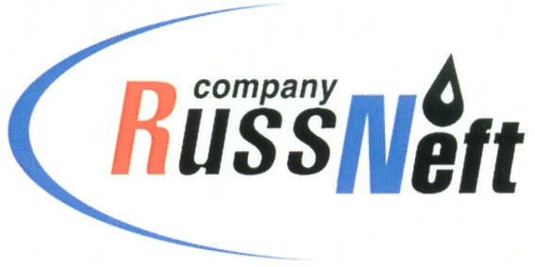
PJSC “RUSSNEFT” PRESS SERVICE

Tel.: (495) 411-63-24; (495) 411-63-21  Fax: (495) 411-63-19  E-mail: pr@russneft.ru  www.russneft.ru | 115054, Moscow,  Pyatnitskaya str., 69

PRESS RELEASE
January 27, 2021

RussNeft added oil reserves by 30 million tonnes in 2020

Incremental reserves at RussNeft totalled 32.6 million tonnes of oil in 2020. Most exploration work in the reporting year was carried out in the Khanty-Mansiysk Autonomous District.

The Company annually implements a significant programme of geological exploration works (E&A), the main sources of which will remain hard-to-recover and unconventional reserves in the medium term. Growth of competencies in the field of exploration and development of such reserves, analysis and summarisation of the results of exploration works carried out allows the company to quickly rank projects, highlighting the most attractive and promising areas (Verkhne-Shapshinskoye, Tagrinskoye, Zapadno-Varioganskoye fields).

In 2020, as part of the prospecting and appraisal stage, the MOGT-3D field seismic survey (FSS) was completed at the Vodorazdelnoye licence area and the flank of the Tagrinskoye field. The total area of prospecting FSS performed exceeds 400 sq km, and processing and interpretation of field and borehole data has begun.

In 2021, cameral work is planned to be completed for comprehensive processing and interpretation of seismic and well data, the results of which will refine the geological model of the Jurassic and Neocomian deposits and make it possible to determine directions for further development in the subsoil areas under study.

About the Company:

PJSC “RussNeft” ranks among the top-10 largest oil companies by crude oil production in Russia.
The Company possesses a well-balanced portfolio of assets located in the key Russian oil and gas provinces (West Siberia, Volga-Urals and Central Siberia) as well as in Azerbaijan.
The headcount of the Company is around 10,000 employees.

PJSC “RussNeft” Press Service
Tel.: (495) 411-63-24, Fax: (495) 411-63-19
E-mail: pr@russneft.ru

