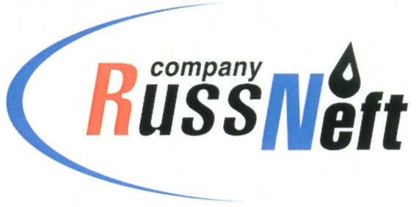

**PJSC “RUSSNEFT” PRESS SERVICE**

|  |  |
| --- | --- |
| **Tel.: (495) 411-63-24; (495) 411-63-21**  **Fax: (495) 411-63-19**  **E-mail: pr@russneft.ru**  [**www.russneft.ru**](http://www.russneft.ru/) | **115054, Moscow,**  **Pyatnitskaya str., 69** |

**PRESS RELEASE**

**January 23, 2025**

RussNeft allocates RUB 7.2 mln for Ulyanovsk and Penza regions social overheads development

In 2024, PJSC “RussNeft” channeled RUB 7.2 mln for the development of the Ulyanovsk and Penza regions social overheads under a charity program in regions of its operations.

Repairs and re-equipment of educational, medical, and social institutions were carried out, and sports and cultural events were held with the financial support of the Ulyanovsk branch.

In particular, funds were used to repair buildings and purchase equipment for schools, kindergartens, and public shelters in Novospassky, Novomalyklinsky, and Melekessky districts of the Ulyanovsk region.

The branch co–financed the holding of the 5th Regional Children`s Paralympic Games, the participation of "Urozhay" football team of the Melekessky district in the Football Competition and Championship of the Ulyanovsk region, and the holding of the 8th Interdepartmental contest "There is such a profession - to defend one`s homeland."

According to the established good tradition, RussNeft honored veterans of the Great Patriotic War living in the Ulyanovsk region.

Charitable funds were used to purchase New Year's gifts for children from low-income families and families in trying circumstances, from Melekessky, Novomalyklinsky, Cherdaklinsky, Nikolaevsky, Radishchevsky districts of the Ulyanovsk and Kuznetsky district of the Penza region, as well as for Paralympic athletes.

**About the Company:**

PJSC “RussNeft” ranks among the top 10 largest oil companies by crude oil production in Russia.

The Company possesses a well-balanced portfolio of assets located in the key Russian oil and gas provinces (West Siberia, Volga-Urals and Central Siberia).

The headcount of the Company is around 7,000 employees.

**Press Service of PJSC "RussNeft"**

**Phone: (495) 411-63-24, Fax: (495) 411-63-19**

**E-mail:**[**pr@russneft.ru**](mailto:pr@russneft.ru)