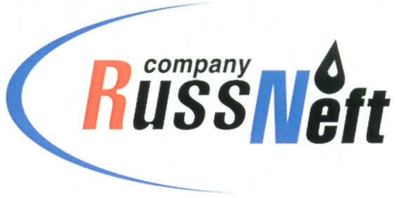
PJSC “RUSSNEFT” PRESS SERVICE

Tel.: (495) 411-63-24; (495) 411-63-21  Fax: (495) 411-63-19  E-mail: pr@russneft.ru  www.russneft.ru | 115054, Moscow,  Pyatnitskaya str., 69

PRESS - RELEASE
September 29, 2022

"RussNeft" assisted in the improvement of military graves in the Ulyanovsk region

PJSC “RussNeft” rendered charitable assistance to the administration of Sukhotereshansky rural settlement of the Nikolaev district of the Ulyanovsk region.

On the territory of the rural settlement in the village of Kuroyedovo there is a cemetery where Soviet soldiers who died during the Great Patriotic War, veterans, invalids, widows of war participants are buried. Residents of the Nikolaev district made a great contribution to the cause of the Victory. 11,470 Nikolaev residents fought at the front, including participants in the defense of the Brest Fortress and Sevastopol, battles near Smolensk and the Dnieper, battles for Moscow and Orel, Kursk and Stalingrad. 5,232 natives of the Nikolaev district did not return home.

Charitable funds allocated by the Ulyanovsk branch of "RussNeft" are aimed at overhauling the fence of the cemetery in the village of Kuroyedovo.

The company systematically implements charitable and sponsorship programs in the areas of its presence.

About the Company:
PJSC “RussNeft” ranks among the top-6 largest oil companies by crude oil production in Russia.
The Company possesses a well-balanced portfolio of assets located in the key Russian oil and gas provinces (West Siberia, Volga-Urals and Central Siberia) as well as in Azerbaijan.
The headcount of the Company is around 8,000 employees.

Press Service of PJSC "RussNeft"
Phone: (495) 411-63-24, Fax: (495) 411-63-19
E-mail: pr@russneft.ru

