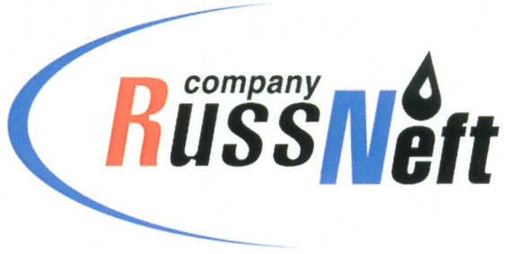
PJSC “RUSSNEFT”
PRESS SERVICE

Tel.: (495) 411-63-24; (495) 411-63-21  Fax: (495) 411-63-19  E-mail: pr@russneft.ru  www.russneft.ru | 115054, Moscow,  Pyatnitskaya str., 69

PRESS - RELEASE
January 24, 2023
RussNeft contributes to the New Year charity event in Raduzhny

RussNeft took part in a charity event to present New Year's gifts to the children from families of small indigenous minorities of the North living in the remote camps of Nizhnevartovsk district.
The event was implemented by the Nizhnevartovsk branch of the Company together with the Rescue of Ugra public organization and the municipal administration of the Nizhnevartovsk district.
The New Year's charity campaign has become traditional: RussNeft annually allocates funds for gifts purchase for young forest cattle camps dwellers. Holding such charity events is a good example of mutually beneficial cooperation between subsoil users and the indigenous population of Ugra.
The Nizhnevartovsk branch of RussNeft produces hydrocarbons on lands of traditional nature use of 60 families of small indigenous minorities of the North. The preservation of the culture, traditions and customs of the indigenous inhabitants of Ugra is one of the major focus areas of the company's social programs.

About the Company:
PJSC “RussNeft” ranks among the top-10 largest oil companies by crude oil production in Russia.
The Company possesses a well-balanced portfolio of assets located in the key Russian oil and gas provinces (West Siberia, Volga-Urals and Central Siberia) as well as in Azerbaijan.
The headcount of the Company is around 8,000 employees.

Press Service of PJSC "RussNeft"
Phone: (495) 411-63-24
Fax: (495) 411-63-19
E-mail: pr@russneft.ru

