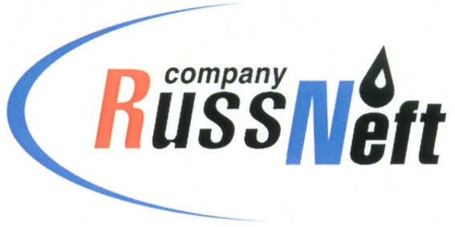
PJSC “RUSSNEFT”
PRESS SERVICE

Tel.: (495) 411-63-24; (495) 411-63-21  Fax: (495) 411-63-19  E-mail: pr@russneft.ru  www.russneft.ru | 115054, Moscow,  Pyatnitskaya str., 69

PRESS - RELEASE
December 1, 2021
RussNeft Group net profit for 9M 2021 grows
5.5-fold up to RUB 23.556 bn

The net profit of RussNeft Group for 9M 2021 amounted to RUB 23.556 bn. In the same period of the previous year, this index made RUB 4.310 bn.
EBITDA of the Group for the reporting period increased 2.8-fold, reaching RUB 29.234 bn. Revenue rose from RUB 89.362 bn to RUB 159.442 bn.
Over the 9 month of 2021, the principle of the debt was repaid on schedule, and current interests were paid in full.
During the period from January to September 2021, capital investments over the Production Block of RussNeft made up RUB 13.354 bn, thereby commissioning 78 new producer wells (an increase of 20 units). Oil output for the reporting period reached 4,920 thousand tons.
In addition, RussNeft allocated over RUB 200 mln for reforestation as part of the global Low-Carbon Development Strategy, aimed at reducing the environmental impact of industry.
The Board of Directors of the Company noted the positive trends in the financial and economic activities of RussNeft over 9 months of 2021.

About the Company:
PJSC “RussNeft” ranks among the top-10 largest oil companies by crude oil production in Russia.
The Company possesses a well-balanced portfolio of assets located in the key Russian oil and gas provinces (West Siberia, Volga-Urals and Central Siberia) as well as in Azerbaijan.
The headcount of the Company is around 8,000 employees.

Press Service of PJSC "RussNeft"
Phone: (495) 411-63-24
Fax: (495) 411-63-19
E-mail: pr@russneft.ru

