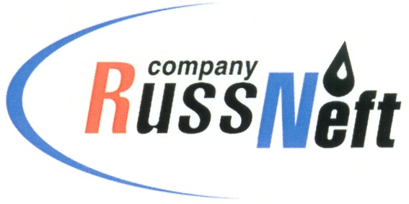
PJSC “RUSSNEFT” PRESS SERVICE

Tel.: (495) 411-63-24; (495) 411-63-21  Fax: (495) 411-63-19  E-mail: pr@russneft.ru  www.russneft.ru | 115054, Moscow,  Pyatnitskaya str., 69

PRESS RELEASE
October 30, 2019

RussNeft supports Children Theater`s Festival in Saratov

"RussNeft" has supported the regional festival-contest of children`s performance groups “Saratov Gems”.
The Saratovneftegaz subsidiary opened the doors of its Rovesnik children`s camp to fifteen theatre companies from 10 municipal districts of Saratov Region, which count for 165 young actors, and their leaders.
The event takes place from October 28th to November 1st within the framework of the Year of Theater in RF that is supported by the Ministry of Culture of Saratov Region and the L.A. Ruslanova Regional Centre of Folk Art.
The diversity of the theatre productions will be presented in the contest programme: from profound dramas to joyful and entertaining interludes, from contemporary stand-ups of one’s own composition to classic literature by Pushkin and Carroll.
Apart from the competition programme, for the festival participants round tables with discourse on the performed plays, meetings with members of the jury, master classes on theatre disciplines from prominent figures of Saratov cultural life have been organized.
The festival-contest aims to ensure preserving and development of amateur theatre, the creation of the new theatres and intensification of the activities of the existing ones, as well as to enhancing stage acting and directing, forming feeling of inclusiveness with the theatre art.

About Company:

PJSC "RussNeft" is among the top 10 largest oil companies in terms of oil production in Russia.
The company has a balanced portfolio of assets in Russia in key oil and gas regions (Western Siberia, Volga-Ural region and Central Siberia), as well as in Azerbaijan.
The number of employees of the Company is about 10, 000 people.

PJSC “RussNeft” Press Service
Tel.: (495) 411-63-24, Fax: (495) 411-63-19
E-mail: pr@russneft.ru

