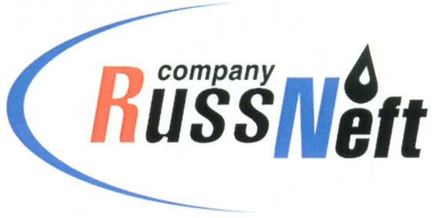
PJSC “RUSSNEFT” PRESS SERVICE

Tel.: (495) 411-63-24; (495) 411-63-21  Fax: (495) 411-63-19  E-mail: pr@russneft.ru  www.russneft.ru | 115054, Moscow,  Pyatnitskaya str., 69

PRESS - RELEASE
August 23, 2022
RussNeft conducts oil spill containment and response exercise

PJSC “RussNeft” have conducted an integrated exercise to test the company's preparedness for actions to be taken to localize and eliminate spills of crude oil and petroleum products in the Saratov region.
The exercise took place not far from the Stepnoye village of the Sovietsky municipal district of the Saratov region, where the company's production facilities are located.
The skills of conducting emergency rescue and other urgent works on oil spill localization and response in case of oil ingress into a water body because of pipeline depressurization, were validated in practice during the exercises. The exercises are held every three years, and are large-scale in terms of the number of forces and means involved.
Under the plan of integrated exercises, employees of the Saratov branch, as well as employees of the Saratov territorial division of the Volga Center ECOSPAS and of the fire emergency response unit were involved in the localization and response to a simulated oil spill.
The validity and coherence of the exercise participant actions were evaluated by a qualified commission, which included representatives of the Russian EMERCOM in the Saratov region, the Ministry of Nature and Ecology of the Saratov region, the territorial bodies of Rosprirodnadzor and Rostechnadzor, as well as a representative of the local administration.
Based on the results of the exercises, the commission concluded that the operator Saratov branch of PJSC RussNeft is ready for oil and petroleum products spill localization and response.

About the Company:
PJSC “RussNeft” ranks among the top-10 largest oil companies by crude oil production in Russia.
The Company possesses a well-balanced portfolio of assets located in the key Russian oil and gas provinces (West Siberia, Volga-Urals and Central Siberia) as well as in Azerbaijan.
The headcount of the Company is around 8,000 employees.

Press Service of PJSC "RussNeft"
Phone: (495) 411-63-24
Fax: (495) 411-63-19
E-mail: pr@russneft.ru

