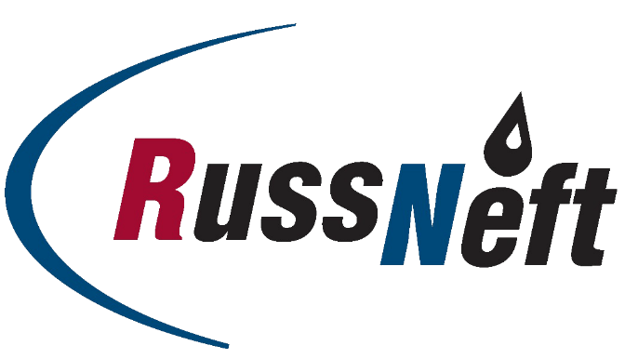

August 27, 2021

PJSC “RussNeft” announces its
IFRS results for 6M 2021

PJSC “RussNeft” (“RussNeft” or “Company”) (MOEX: RNFT) publishes unaudited interim abbreviated consolidated financial statements for 6M 2021 prepared in compliance with International Financial Reporting Standards (IFRS).

Highlights:
- EBITDA grew more than 4.5x making up RUB 33.2 bn.
- Oil production was 3.4 mln tons.
- CAPEX recovered to RUB 9.3 bn.
- Net debt/EBITDA ratio was at 1.2.

Key performance indicators
Financials
RUB Billion | 6M 2021 | 6M 2020
Revenue | 123,9 | 60,1
EBITDA | 33,2 | 6,8
EBITDA margin | 27% | 11%
Profit attributable to shareholders of the Parent company | 13,6 | (13,2)
Adjusted profit/(loss) | 17, 4 | (17, 3)

In H1 2021 RussNeft demonstrated significant revenue growth (+ RUB 64 bn) on the YoY basis. The growth of the factor is mainly associated with the rise in world oil prices and domestic market oil prices (Urals average price was $ 63.4/bbl in 6M 2021 versus $ 39.0/bbl in 6M 2020).
The profit attributable to the shareholders of the Parent company significantly exceeded the H1 2020 indicator, having reached RUB 13.6 bn against RUB 13.2 billion of loss last year.
Adjusted profit for the reporting period made up RUB 17.4 bn, driven mainly by oil prices recovery after oil shock in 2020.
EBITDA amounted to RUB 33.2 bn, a 4.5x YoY increase, exceeding the factors of pre-crisis period.

Operating results
Operating results | 6м 2021 | 6М 2020
Crude oil production, mln t | 3,427 | 3,563
Oil production in RF | 3,191 | 3,319
Oil production under PSAs in Azerbaijan | 0,236 | 0,244
Gas production, mln m3 | 1 021 | 1 195

A slight decrease in oil production against the same period last year (-4%) or 136 k tons of oil by volume was due to the OPEC + deal. The decrease in gas production volumes against H1, 2020 (-15%) is also associated with oil production restrictions.
Capital investments
Capital investments (assimilation), RUB bln | 6M 2021 | 6М 2020
PRODUCTION DRILLING | 6,9 | 5,5
BASЕ PRODUCTION | 1,1 | 0,8
WELL INTERVENTIONS | 1,1 | 0,7
GAS PROGRAMME | 0,2 | 0,003
GEOLOGICAL AND EXPLORATION WORKS | 0,03 | 0,5
Total | 9,3 | 7,5

The strategy of the Company provides for intense investment activity aimed at maintaining the rate of production.
Debt portfolio
CQUR BANK LLC provided a loan to the company for the sum of USD 1.126 bn. According to the terms of the loan, from March 2021, the Company began to repay the principal of the loan in equal quarterly installments. All loan obligations are timely and fully executed.

The full version of IFRS consolidated financial statements is available at:
http://russneft.ru/shareholders/financial_statements/
Contacts for media  +7 (495) 411- 63- 24  pr@russneft.ru | Contacts for investors  +7 (495) 411-63-09  ir@russneft.ru

About the Company:
PJSC “RussNeft” ranks among the largest oil companies by crude oil production in Russia.
The Company possesses a well-balanced portfolio of assets located in the key Russian oil and gas provinces (West Siberia, Volga-Urals and Central Siberia) as well as in Azerbaijan.
2P reserves of the Company exceed 200 million tons (SPE). The number of the Company’s personnel exceeds 8,000.
The authorized capital of the Company contains 294,120,000 of ordinary shares and 98,032,000 of the privileged shares herewith 20% of the voting shares are traded at the Moscow Exchange (MOEX:RNFТ).

_____________________________________
5. Reserves under international projects are not incl.

Including production from international projects
Acc.to data of managing accounts
Excluding FX differences and revaluation of financial instruments’ fair value
Acc. to the management accounting

