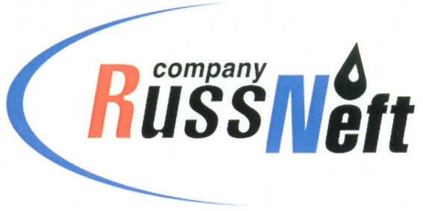
PJSC “RUSSNEFT”
PRESS SERVICE

Tel.: (495) 411-63-24; (495) 411-63-21  Fax: (495) 411-63-19  E-mail: pr@russneft.ru  www.russneft.ru | 115054, Moscow,  Pyatnitskaya str., 69

PRESS - RELEASE
March 16, 2023
RussNeft allocates funding to the Victory Day celebration

The Saratov branch of PJSC “RussNeft” provides financial support for events dedicated to the Victory Day.
On an annual basis, the company provides charity support to the Saratov Museum of Military and Labor Glory. The museum, located on Sokolova Gora, is a complex social and cultural space narrating about the past and present of the region. Alongside with the museum pavilions dedicated to the military and labor feats of natives of Saratov, there are "The Cranes" memorial, an open-air exhibition of military and agricultural equipment, the National Village ethnographic complex.
Over the past 5 years, financial support to the museum has allowed to solve a number of tasks: to install a broadcasting system in the park on the territory of more than 80 hectares, to fit out with a video surveillance security system, to improve the territory itself and the exposition of Victory Park, to carry out operating repairs of pavilions, to do out new museum stands.
For several years now, one of the recipients of the Company's charity support has been the Saratov Regional Clinical Hospital for War Veterans.
The districts of the Company's activity in the Saratov region will not be neglected either. They, as before, will be assisted in preparing for the May 9 holiday. The support of RussNeft made it possible to repair and reconstruct local monuments and memorials to the heroes of the Great Patriotic War. Thus, in recent years, with the participation of the Company, monuments have been erected and reconstructed in the settlements of Gagarinsky, Atkarsky, Lysogosky, Tatishchevsky, Sovetsky, Perelyubsky districts.
RussNeft's charitable initiatives provide a basis for commemoration of the feats of compatriots and patriotic education of young generation..

About the Company:
PJSC “RussNeft” ranks among the top-10 largest oil companies by crude oil production in Russia.
The Company possesses a well-balanced portfolio of assets located in the key Russian oil and gas provinces (West Siberia, Volga-Urals and Central Siberia) as well as in Azerbaijan.
The headcount of the Company is around 8,000 employees.

Press Service of PJSC "RussNeft"
Phone: (495) 411-63-24
Fax: (495) 411-63-19
E-mail: pr@russneft.ru

