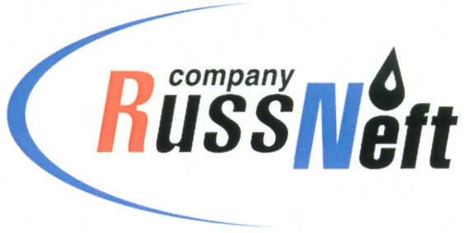
PJSC “RUSSNEFT” PRESS SERVICE

Tel.: (495) 411-63-24; (495) 411-63-21  Fax: (495) 411-63-19  E-mail: pr@russneft.ru  www.russneft.ru | 115054, Moscow,  Pyatnitskaya str., 69

PRESS RELEASE
September 30, 2020

RussNeft supported the school of counselor skills in Saratov

PJSC “RussNeft” supported the counselors upgrade project to organize work with children in conditions of coronavirus pandemic.

In Saratov, thirty six university students of the city and municipal districts of the region were trained on the basis of the Company's supervised children's health center "Rovesnik".

The offsite school of counseling skills, organized by the health center staff, combined the educational process with active recreation, creative activities and sports.

The classes were held in strict accordance with the recommendations on the organization of work in conditions of viral infection spread.

Innovations in pedagogical practice became one of the most important training clusters for Saratov region university students.

About the Company:

PJSC “RussNeft” ranks among the top-10 largest oil companies by crude oil production in Russia.
The Company possesses a well-balanced portfolio of assets located in the key Russian oil and gas provinces (West Siberia, Volga-Urals and Central Siberia) as well as in Azerbaijan.
The headcount of the Company is around 10,000 employees.

PJSC “RussNeft” Press Service
Tel.: (495) 411-63-24, Fax: (495) 411-63-19
E-mail: pr@russneft.ru

