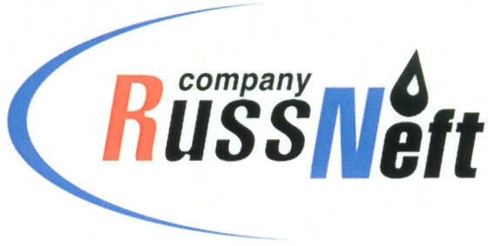
PJSC “RUSSNEFT” PRESS SERVICE

Tel.: (495) 411-63-24; (495) 411-63-21  Fax: (495) 411-63-19  E-mail: pr@russneft.ru  www.russneft.ru | 115054, Moscow,  Pyatnitskaya str., 69

PRESS RELEASE

July 31, 2020

RussNeft has fulfilled its social obligations to indigenous peoples of the North

This year PJSC "RussNeft" allocated more than 17 million rubles for compensation payments to indigenous peoples of the North, whose representatives live in the license areas of the Company.
Funds of RussNeft were directed to purchase equipment, construction materials and fuel and lubricants necessary at forest cattle camps.
In the territory of the Company's presence in Nizhnevartovsk district of Yugra 58 families of indigenous peoples of the North traditionally live. Compensation payments are made on the basis of federal, district laws and agreements concluded with each of the families.
Besides, in 2020 RussNeft provided financial support to the "Inter-settlement Center of National Crafts" in Agan, becoming a partner and founder of special prizes of the district competition of professional skills among reindeer herders for the Cup of the Governor of Ugra.

About the Company:

PJSC “RussNeft” is a member of SAFMAR Industrial and Financial Group of Mikhail Gutseriev.
The Company possesses a well-balanced portfolio of assets located in the key Russian oil and gas provinces (West Siberia, Volga-Urals and Central Siberia) as well as in Azerbaijan.
The Company's 2P reserves exceed 200 million tonnes (SPE). The headcount of the Company is around 10,000 employees.

PJSC “RussNeft” Press Service
Tel.: (495) 411-63-24, Fax: (495) 411-63-19
E-mail: pr@russneft.ru

